附件1

国外智能制造产业100项最新专利项目

1、Smart Factory FOMs Package and Method for Smart Manufacturing Innovation
标题（翻译）：用于智能制造创新的智能工厂FOMS封装和方法
摘要：The present invention relates to a smart factory FOMs package for smart production innovation and a method thereof, and a factory operation management (FOMs) of a smart factory for smart production innovation. Factory Oporation Management) In a package, a data collection layer (Data Gathering Layer) (10) for collecting information contributing to production in a factory. The data collection layer 10 and the database layers Database (DB) Layer and 20 for storing and processing the collected data. The database layer 20 analyzes the data stored in the database, and analyzes the data provided in the factory, Analysis Layer, and the information analysis layer 30 for analyzing the information provided in the factory. And. The present invention is characterized by operating a cloud (1500) for remotely monitoring and controlling operation based on analyzed information in the information analysis layer.
摘要（翻译）：本发明涉及用于智能生产创新的智能工厂FOMS封装及其方法，以及用于智能生产创新的智能工厂的工厂操作管理(FOM)。 工厂经营管理)，收集对工厂的生产有贡献的信息的数据收集层(数据收集层)(10)。 数据收集层10和数据库层数据库(DB)层20用于存储和处理收集的数据。 数据库层20分析存储在数据库中的数据，并分析工厂，分析层和信息分析层30中提供的数据，以分析工厂中提供的信息。 以及。 本发明的特征在于，基于信息分析层中的分析信息来操作用于远程监视和控制操作的云(1500)。
首页附图：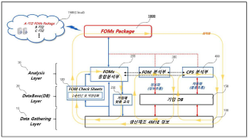
申请人：(주) 디지털팩토리
申请号：KR1020200032342
专利类型：发明申请
申请日：2020-03-17
公开（公告）号：KR1020210115917A
公开（公告）日：2021-09-27

2、NETWORK DEVICE AND WIRELESS COMMUNICATION DEVICE FOR CYCLIC COMMUNICATION
标题（翻译）：用于循环通信的网络设备和无线通信设备
摘要：The present application relates to wireless communications suitable for smart manufacturing and industrial automation. In particular, the application proposes a wireless communication device (UE) and a network device (BS), in particular suitable for cyclic communication. The BS is configured to provide a first information defining a hopping sequence to a UE, and to provide a second information to the UE defining when the hopping sequence should be repeated, in particular periodically repeated. The UE is accordingly configured to receive the first information from the BS, and to receive the second information from the BS. The hopping sequence specifies at least two spatial resources and/or at least two radio resources, which the UE is configured to use for transmissions to and/or from the BS.
摘要（翻译）：本申请涉及适用于智能制造和工业自动化的无线通信。 具体地，本申请提出了一种无线通信设备(UE)和一种网络设备(BS)，特别适用于循环通信。 BS被配置为向UE提供定义跳跃序列的第一信息，并且向UE提供定义何时应当重复跳跃序列，特别是周期性地重复跳跃序列的第二信息。 因此，UE被配置为从BS接收第一信息，并且从BS接收第二信息。 跳变序列指定至少两个空间资源和/或至少两个无线电资源，UE被配置为用于到BS的传输和/或从BS的传输。
首页附图：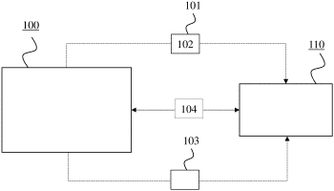
申请人：HUAWEI TECHNOLOGIES CO LTD
申请号：US17238761
专利类型：发明申请
申请日：2021-04-23
公开（公告）号：US20210242900A1
公开（公告）日：2021-08-05

3、CYBER-PHYSICAL SYSTEM-BASED REMOTE CONTROL FRAMEWORK FOR ROBOTS
标题（翻译）：基于计算机物理系统的机器人远程控制架构
摘要：A cyber-physical system (CPS)-based remote control system for a robot is provided to solve the problems that the traditional teaching and control methods for an industrial robot fail to meet the requirements of intelligent manufacturing and lack in the visual scene. The CPS-based remote control system combines with the visual virtual environment to improve the user experience, which not only improves an efficiency of the control system for the robot, but also brings a new interaction mode with robots in the field of intelligent manufacturing.
摘要（翻译）：一种基于CPS的机器人远程控制系统，以解决传统工业机器人教学和控制方法不能满足智能制造的要求，缺乏可视化场景的问题。 本实用新型结合可视化的虚拟环境，提高了用户体验，不仅提高了机器人控制系统的效率，而且在智能制造领域带来了一种新的与机器人的交互方式。
首页附图：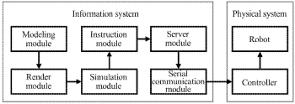
申请人：HARBIN INSTITUTE OF TECHNOLOGY
申请号：US17139610
专利类型：发明申请
申请日：2020-12-31
公开（公告）号：US20210229286A1
公开（公告）日：2021-07-29

4、Building Method of Plastic Working Process Information Based on AI
标题（翻译）：一种基于AI的塑料加工过程信息的构建方法
摘要：The present invention relates to a AI-based plastic processing process information construction method. The present invention selectively stores the analysis result of a plastic processing simulator in process design DB. AI : The optimal process design system is connected to simulation software to obtain detailed analysis results related to the process. The method of AI, wherein a candidate process design generated by the three-based optimal process design system is automatically stored in the process design DB. Acquisition of operating information of a process design in a smart manual packing system DB, The process design information stored in the process design AI may be stored in an abbreviated form, and an analysis and production information relating to a plurality of processes may be stored in one file.
摘要（翻译）：本发明涉及一种基于AI的塑料加工过程信息构建方法。 本发明在工艺设计DB中有选择地存储塑料加工模拟器的分析结果。 AI：最优工艺设计系统连接到仿真软件，以获得与工艺相关的详细分析结果。 AI的方法，其中由基于三个的最优工艺设计系统生成的候选工艺设计被自动存储在工艺设计DB中。 在智能手工包装系统DB中获取工艺设计的操作信息，存储在工艺设计AI中的工艺设计信息可以缩写形式存储，并且可以在一个文件中存储与多个工艺相关的分析和生产信息。
首页附图：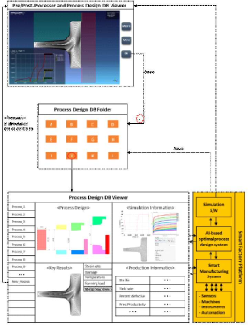
申请人：경상국립대학교산학협력단
申请号：KR1020200006401
专利类型：发明申请
申请日：2020-01-17
公开（公告）号：KR1020210092917A
公开（公告）日：2021-07-27

5、Method for generating the Asset Administration Shell(AAS) in a smart manufacturing system
标题（翻译）：用于在智能制造系统中生成资产管理外壳(AAS)的方法
摘要：The present invention relates to a method for implementing a asset management shell AAS of a smart manufacturing system. A asset management shell AAS (Asset Administration Shell) representing a manufacturing asset is provided to digitize a production system and efficiently exchange data between heterogeneous assets. To this end, the present invention proposes to arrange asset management shells AAS on a smart manufacturing system and digitize them. AAS Is implemented using AutomationML (Automation Markup Language) and OPC UA (Open Platform Communication Unified Architecture). Here, AutomationML denotes an information model of AAS for each asset, and OPC UA is used to provide a communication interface for AAS.
摘要（翻译）：本发明涉及一种用于实现智能制造系统的资产管理外壳AAS的方法。 提供了一种表示制造资产的资产管理外壳AAS(资产管理外壳)，以使生产系统数字化并在异构资产之间有效地交换数据。 为此，本发明提出在智能制造系统上布置资产管理外壳AAS并将其数字化。 AAS使用AutomationML(自动标记语言)和OPCUA(开放平台通信统一体系结构)来实现。 这里，automationML表示每个资产的AAS的信息模型，并且OPCUA用于为AAS提供通信接口。
首页附图：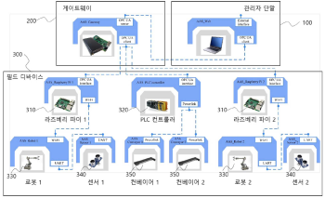
申请人：IUCF HYU ERICA CAMPUS
申请号：KR1020200005373
专利类型：发明授权
申请日：2020-01-15
公开（公告）号：KR102280440B1
公开（公告）日：2021-07-21

6、SYSTEM FOR PROVIDING SMART MANUFACTURING SOLUTION FOR FACTORYLESS MANUFACTURING COMPANIES
标题（翻译）：为无工厂制造公司提供智能制造解决方案的系统
摘要：A smart manufacturing solution system for a factory-free manufacturing company is provided to offer a won -stop (One-Stop) solution for product development, production process, mass production, and data management by integrating all manufacturing activities and services within a product life cycle for a factory-free manufacturing company. A production company selection unit selects and selects a request company and at least one manufacturing company based on the product development request information requested from the requesting company for the production process and production line production line. The present invention relates to a smart manufacturing solution system including a manufacturing information providing management unit for acquiring production field information and manufacturing data from a predetermined manufacturing company through a production company selection unit and providing real-time information to a requesting company.
摘要（翻译）：本发明提供了一种用于无工厂制造公司的智能制造解决方案系统，其通过集成用于无工厂制造公司的产品生命周期内的所有制造活动和服务来提供用于产品开发，生产过程，批量生产和数据管理的优胜-停止(一站式)解决方案。 生产公司选择单元基于从请求公司针对生产过程和生产线请求的产品开发请求信息，选择并选择请求公司和至少一个生产公司。 本发明涉及一种智能制造解决方案系统，包括制造信息提供管理单元，用于通过生产公司选择单元从预定的生产公司获取生产现场信息和制造数据，并向请求的公司提供实时信息。
首页附图：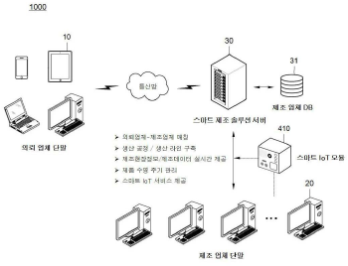
申请人：LEE HYUN KYU
申请号：KR1020200144499
专利类型：发明授权
申请日：2020-11-02
公开（公告）号：KR102269616B1
公开（公告）日：2021-06-28

7、IoT GATEWAY SYSTEM FOR INDUSTRIAL
标题（翻译）：用于工业的物联网网关系统
摘要：An industrial IoT gateway system, comprising : an edge device generating edge data comprising at least one of sensor data and facility data, with an industrial IoT gateway system for edge computing, handling data at edge devices of various protocol types independently of protocols. Cloud service, web service, smart manufacturing system (MES) service, and cloud providing at least one service of ERP services The edge data is processed to process the edge data. The method may further include transmitting the edge data to the cloud.
摘要（翻译）：本发明作为一种工业物联网网关系统，将来自各种协议类型的边缘设备的数据与协议无关。一种进行边缘计算的工业物联网网关系统，产生边缘数据的边缘设备，该边缘设备具备传感器数据和设备数据中的至少一种；云提供云服务、Web服务、智能制造系统(MES)服务、和ERP服务中至少任何一种服务；以及可包括接收所述边缘数据以处理所述边缘数据，并向所述云发送所述边缘数据的边缘网关。
首页附图：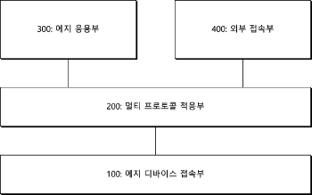
申请人：DODOONE CO LTD
申请号：KR1020190156680
专利类型：发明授权
申请日：2019-11-29
公开（公告）号：KR102262321B1
公开（公告）日：2021-06-08

8、HYBRID HYDROSTATIC ROTARY ACTUATOR APPARATUS
标题（翻译）：混合式静液压旋转致动器装置
摘要：There is disclosed a rotary actuator apparatus for hydraulically or pneumatically rotating a robotic joint. In an embodiment the apparatus comprises : a curved piston rotatably coupled to an axel shaft, and positioned within a curved piston chamber; resilient barrier modules are adapted to separate the curved piston within the curved piston chamber from first and second hydraulic or pneumatic chambers on either side of the curved piston chamber; whereby, in use, the curved piston is configured to rotate about the axel shaft upon hydraulic or pneumatic pressure being applied to at least one of the first and second hydraulic or pneumatic chambers.
摘要（翻译）：本发明公开了一种用于液压地或气动地旋转机器人关节的旋转致动器装置。 在一个实施例中，该装置包括：弯曲活塞，其可旋转地联接到轴，并定位在弯曲活塞腔内； 弹性阻挡模块适于将弯曲活塞腔内的弯曲活塞与弯曲活塞腔两侧的第一和第二液压或气动腔隔开； 由此，在使用中，当液压或气动压力施加到第一和第二液压或气动腔室中的至少一个时，弯曲活塞被构造成绕轴杆旋转。
首页附图：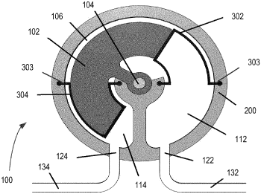
申请人：MIRSEE ROBOTICS INC
申请号：US17151542
专利类型：发明申请
申请日：2021-01-18
公开（公告）号：US20210140452A1
公开（公告）日：2021-05-13

9、MR-Smart Manufacturing Training System for Smart Manufacturing Convergence Technology Training Combined with Automation PLC Technology and IOT Technology
标题（翻译）：结合自动化PLC技术和物联网技术的智能制造融合技术培训的MR-SMART制造培训系统
摘要：PLC Smart manufacturing training apparatus for smart manufacturing fusion technology using automated IOT technology and MR - technology is disclosed. In detail 4, it is an object of the present invention to provide an education device capable of basic and application learning of a smart factory, a smart farm, a smart grid, and the like by fusing technologies that interface an open source ICT technology and an automated PLC technology that initializes a smart manufacturing process. A smart factory, a smart farm, a smart grid, and an education device using the same are provided to enable a smart factory to learn a core technology of a smart factory based on a 4 PLC technology key technology and a smart manufacturing process by using an OCC ICT technology.
摘要（翻译）：公开了用于使用自动化物联网技术和MR技术的智能制造融合技术的PLC智能制造实训装置。 详细地4， 本发明的一个目的是提供一种能够对智能工厂进行基本和应用学习的教育设备， 一种智能农场，智能电网等，其通过融合接口为开放源ICT技术和初始化智能制造过程的自动PLC技术的技术来实现。 智能工厂， 本发明提供了一种智能农场，智能电网和使用该智能农场的教育设备，以使智能工厂能够基于4PLC技术关键技术和智能制造工艺，利用OCC ICT技术学习智能工厂的核心技术。
首页附图：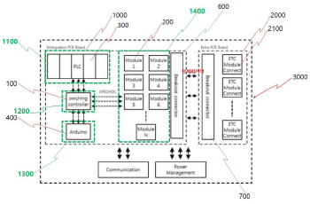
申请人：TESNTES CO LTD
申请号：KR1020190138240
专利类型：发明申请
申请日：2019-10-31
公开（公告）号：KR1020210052113A
公开（公告）日：2021-05-10

10、ALIGNER APPARATUS MANUFACTURING SYSTEM USING ARTIFICIAL INTELLIGENCE AND METHOD USING THE SAME
标题（翻译）：使用人工智能的对准器设备制造系统和使用该系统的方法
摘要：Provided are a system and a method for manufacturing a calibration device using artificial intelligence. A system for manufacturing a calibration device using artificial intelligence according to an embodiment of the present invention obtains a patient's dentition structure as 3-dimensional image data. A data processing unit receives the 3-dimensional image data to output image data, a database unit storing a plurality of clinical data, a database unit storing a plurality of clinical data, and an output unit for producing a calibration device based on an output value of the image analysis unit.
摘要（翻译）：本发明提供一种使用人工智能制造校准装置的系统和方法。 根据本发明实施例的用于使用人工智能制造校准装置的系统获得作为三维图像数据的患者的齿列结构。 数据处理单元接收三维图像数据以输出图像数据， 数据库单元，用于存储多个临床数据；数据库单元，用于存储多个临床数据；以及输出单元，用于基于图像分析单元的输出值来产生校准装置。
首页附图：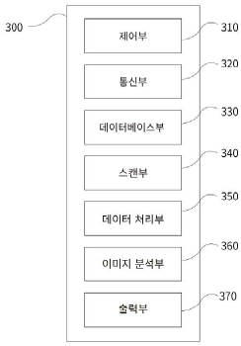
申请人：REALIGNER CO LTD
申请号：KR1020210016406
专利类型：发明授权
申请日：2021-02-04
公开（公告）号：KR102250314B1
公开（公告）日：2021-05-10

11、Smart Fabrication System with Smart Powder Cells
标题（翻译）：具有智能粉末电池的智能制造系统
摘要：The present invention relates to a smart flower bed system of a smart flowerpot cell combination type, in which smart flowerpot cells are simply combined to provide a smart flower bed wanted by a user and water of a water tank installed in each smart flowerpot cell is shared (for example, the water is supplied from a smart flowerpot cell remaining a lot of water therein to a smart flowerpot cell requiring water) to increase water supply efficiency to enable the user to easily manage the flower bed. According to the present invention, the smart flower bed system comprises : a connection frame (102); a first smart flowerpot cell (104) detachably placed on the lower surface of a lower plate of the connection frame (102); a second smart flowerpot cell (106) detachably placed on the upper surface of an upper plate of the connection frame (102) at a predetermined interval from the first smart flowerpot cell (104); a first connection pipe installed on one side of a water tank of the first smart flowerpot cell (104) and one side of a water tank of the second smart flowerpot cell (106) to couple the first and second smart flowerpot cells (104, 106); a third smart flowerpot cell (108) placed on a side surface of the first smart flowerpot cell (104); and a fourth smart flowerpot cell (112) placed on a side surface of the third smart flowerpot cell (108).
摘要（翻译）：提供了一种与智能花盆单元结合的智能花盆系统，通过简单地将智能花盆单元与智能花盆单元结合，使得用户能够容易地管理植物，从而通过提高供水效率和管理效率，使得用户能够容易地管理植物。 通过共享安装在每个智能花盆单元102内的水容器的水，植物容易，从而通过提高智能花盆单元的供水效率，有利于植物的管理。 代理102智能罐单元(1)可拆卸地定位在连接框架(104)的底板的底表面上。 药品1智能罐单元104可拆卸地放置在连接框架102的上表面上，与K2智能罐单元106相距预定距离。 1： 第一连接管104安装在第一智能花盆单元2的水箱一侧，并安装在智能花盆单元106的水箱一侧， 以及将第一智能花盆单元1106和第二智能花盆单元1104连接到第一智能花盆单元(160S2)。 药物1智能罐单元104位于(3)智能罐单元108的侧面。 代理3包括位于智能罐单元4112的侧表面上的代理108等。
首页附图：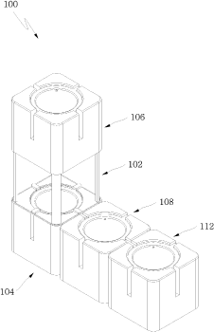
申请人：장철준
申请号：KR1020180121761
专利类型：发明授权
申请日：2018-10-12
公开（公告）号：KR102238887B1
公开（公告）日：2021-04-12

12、METHOD FOR MAKING DRIP COFFEE USING THE ARTIFICIAL INTELLIGENCE AND COMPUTING DEVICE USING THE SAME
标题（翻译）：使用人工智能制造点滴咖啡的方法和使用该方法的计算设备
摘要：AI : When an order code for (a) specific drip coffee is input, the computing device supports the transfer device to place at least a portion of a drip coffee container into which a particular coffee powder corresponding Dripper to a particular recipe information of the particular drip coffee is entered at a predetermined location. (b) The method of claim UR, further comprising : moving the nozzle in a state where UR robots discharge the water connected to 1 robots, so that the nozzles are moved according 1 motion paths corresponding to the specific recipe information, and water is sprayed on the top of the specific coffee powder according 1 motion paths. (c) is a flowchart illustrating an (i) image capturing apparatus according to 1 embodiments of the present invention, wherein a state of the specific coffee powder sprayed by the AI-th motion path and (ii) is input to AI 1 to classify the state of the specific coffee powder into a specific state class among predetermined state classes. The apparatus (d) of claim UR, wherein the computing device supports the AI-robot to move the nozzle according 2-th motion path corresponding to the particular state class classified by the three-way robot, and controls opening and closing of the nozzle in a state in which the nozzle moves according 2 2-motion path. Are a drip coffee manufacturing method and a computing device using the same.
摘要（翻译）：AI： 当输入(a)特定点滴咖啡的订单代码时， 所述计算设备支持所述传送设备将滴注咖啡容器的至少一部分放置在预定位置处，在所述滴注咖啡容器中输入与所述特定滴注咖啡的特定配方信息相对应的特定咖啡粉滴注器。 (b)权利要求UR的方法， 还包括： 在UR机器人排出与1个机器人连接的水的状态下移动喷嘴，使得喷嘴按照与特定配方信息对应的1个运动路径移动，并且按照1个运动路径将水喷射到特定咖啡粉的顶部。 (c)是示出(i)根据本发明的1个实施例的图像捕获设备的流程图， 其中由第AI运动路径喷射的特定咖啡粉的状态和(ii)被输入AI1，以将特定咖啡粉的状态分类为预定状态类别中的特定状态类别。 6.根据权利要求所述的装置(D)， 其中，计算装置支持AI-机器人按照与由三向机器人分类的特定状态类别相对应的第2运动路径移动喷嘴， 以及在喷嘴按照2个2运动路径运动的状态下控制喷嘴的打开和关闭。 一种点滴咖啡制造方法及使用该点滴咖啡制造方法的计算装置。
首页附图：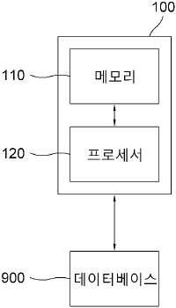
申请人：T ROBOTICS CO LTD
申请号：KR1020200028678
专利类型：发明授权
申请日：2020-03-06
公开（公告）号：KR102236660B1
公开（公告）日：2021-04-06

13、METHOD FOR MANUFACTURING CUTTING TOOL
标题（翻译）：切削工具的制造方法
摘要：Disclosed is a method of manufacturing a cutting tool. According to one embodiment of the present invention, the method of manufacturing the cutting tool, in a method of manufacturing the cutting tool based on an artificial intelligence, comprises : a step of primarily cut raw materials by controlling a first processing process facility based on a design with a control apparatus inputted; a step of photographing an image of the raw materials cut primarily by rotating by 360 degrees as the control apparatus controls a camera in the control apparatus; a step of generating a first input signal based on the results of photographing by the control apparatus; a step where the control apparatus inputs a first input signal into a pre-learned convolution neural network in an embedded computer of the control apparatus; a step where the control apparatus inputs an output value of the convolution neural network into one of a first, second, and third neural networks which are pre-learned in the embedded computer; a step where the control apparatus acquires a first output signal based on the input results for the neural networks; a step where the control apparatus secondarily cuts the raw materials by controlling a second processing process facility based on the first output signal; a step where the control apparatus performs thermal treatment by controlling a thermal treatment machine for the cutting tool product generated as a result of the secondary cutting process; a step where the control apparatus finally grinds the cutting tool product by controlling a grinder; a step where the control apparatus coats a surface of the cutting tool product by controlling a coating machine; and a step where the control apparatus stores a feedback of the manufacturer on the first input signal, the first output signal, and the processing results in a blockchain network. The present invention aims to provide the method of manufacturing the cutting tool, which is able to increase accuracy and efficiency of manufacturing the cutting tool.
摘要（翻译）：本发明公开了一种切削工具的制造方法。 根据一个实施例的切削工具制造方法是基于人工智能制造切削工具的方法。 控制装置1将卷积神经网络的输出值1输入到预学习规则1中的一个， 360°嵌入式计算机， 并根据图像采集结果，通过控制装置的1个部分，根据嵌入式计算机1中神经网络的输入结果，控制控制装置获得输出信号1， 控制装置将卷积神经网络的2个输出值3传送给嵌入式计算机1中的一个预学习卷积神经网络。 控制器1根据第2输出信号控制加工设备2对原料进行2次切割， 控制由于二次切削而产生的切削工具产品中的热处理机， 控制装置控制刀具1产品的表面，控制1涂覆机，并将生产厂家对输出信号的反馈和处理结果存储在块链网络中。
首页附图：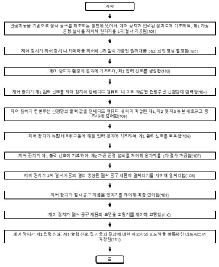
申请人：SAMDO CO LTD
申请号：KR1020200017231
专利类型：发明授权
申请日：2020-02-12
公开（公告）号：KR102193189B1
公开（公告）日：2020-12-18

14、SYSTEM FOR ASSESSING SMART FACTORY AND SUGGESTING IMPROVEMENT METHOD BASED ON LAYOUT IN CLOUD
标题（翻译）：一种基于云中布局的智能工厂评估及改进建议系统
摘要：The present invention provides a system for diagnosing a smart factory and suggesting an improvement plan based on a layout in a cloud. According to an embodiment of the present invention, the system for diagnosing a smart factory comprises a layout setup unit, a diagnosis model generation unit, a smart index calculation unit, and a smart index visualization unit. The layout setup unit generates a layout in which one or more icons representing one or more components of a real factory are arranged as the structure of the real factory. The diagnosis model generation unit classifies the one or more icons into one or more groups in accordance with a type, and generates one or more surveys corresponding to the one or more groups for the one or more icons. The smart index calculation unit calculates a smart index of the real factory for evaluating a smart level of the real factory based on information on the real factory acquired through the one or more surveys. The smart index visualization unit visualizes the smart index to display the smart index on a screen.
摘要（翻译）：本发明提供了一种用于基于云上的布局来诊断和改进智能工厂的系统。 根据本发明实施例的智能工厂诊断系统包括布局设置单元。 本发明涉及诊断模型生成单元，智能指数计算单元和智能指数可视化单元。 布局设置单元生成布局，在该布局中，表示实际工厂的一个或多个组件的一个或多个图标被布置在实际工厂结构中。 诊断模型生成单元根据类型将一个或多个图标分类为一个或多个组，并为一个或多个图标生成与一个或多个组相对应的一个或多个问题。 智能指数计算器基于通过一个或多个调查问题获得的关于实际工厂的信息，计算用于评估实际工厂的智能水平的实际工厂的智能指数。 智能指数可视化单元可视化智能指数以显示用于在屏幕上显示的智能指数可视化单元。
首页附图：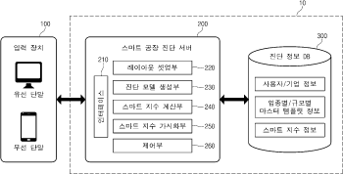
申请人：IGI KOREA
申请号：KR1020190154714
专利类型：发明授权
申请日：2019-11-27
公开（公告）号：KR102183328B1
公开（公告）日：2020-11-26

15、Method, apparatus, and system for object tracking sensing using broadcasting
标题（翻译）：使用广播进行目标跟踪感测的方法，装置和系统
摘要：Method, apparatus and systems for object tracking are disclosed. In one example, a system for tracking a plurality of objects in a venue is disclosed. The system comprises a transmitter configured for transmitting a series of probe signals in a broadcasting manner through a wireless multipath channel, wherein the wireless multipath channel is impacted by a movement of at least one of the plurality of objects in the venue; and a plurality of heterogeneous target wireless receivers each of which is associated with an object of the plurality of objects in the venue. Each of the plurality of heterogeneous target wireless receivers is configured for : receiving the series of probe signals through the wireless multipath channel between the heterogeneous target wireless receiver and the transmitter, obtaining at least one time series of channel information (TSCI) of the wireless multipath channel based on the series of probe signals received by the heterogeneous target wireless receiver, and tracking the object associated with the heterogeneous target wireless receiver based on the at least one TSCI.
摘要（翻译）：公开了用于对象跟踪的方法，装置和系统。 在一个示例中，公开了一种用于跟踪场所中的多个对象的系统。 所述系统包括：发射机，被配置为通过无线多径信道以广播方式发射一系列探测信号，其中所述无线多径信道受到所述场所中的所述多个对象中的至少一个的移动的影响； 以及多个异类目标无线接收器，每个异类目标无线接收器与所述场所中的所述多个对象中的一个对象相关联。 所述多个异构目标无线接收机中的每一个被配置用于： 通过异构目标无线接收机和发射机之间的无线多径信道接收一系列探测信号， 基于由异构目标无线接收机接收的探测信号序列来获得无线多径信道的信道信息(TSCI)的至少一个时间序列，以及基于至少一个TSCI来跟踪与异构目标无线接收机相关联的对象。
首页附图：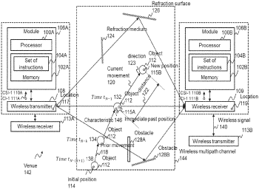
申请人：ORIGIN WIRELESS INC
申请号：US16446589
专利类型：发明授权
申请日：2019-06-19
公开（公告）号：US10742475B2
公开（公告）日：2020-08-11

16、The smart production system and method for proximity sensor
标题（翻译）：用于接近传感器的智能生产系统和方法
摘要：According to the present invention, a proximity sensor smart manufacturing system is used to manufacture a proximity sensor for measuring a distance wherein the proximity sensor includes an LC oscillator (10) that has a coil (11), a capacitor (12) and a resistor (13), a detection unit (20) that detects a change in a sine wave generated in the LC oscillator (10) according to the distance between the LC oscillator (10) and a metal body, and an output unit (30) that outputs a change detected by the detection unit (20). The system includes : an automatic distance control device (110) that stores a set distance value and compares a distance value of a target metal body measured by the proximity sensor with a set distance value; and a laser trimming device (120) for adjusting oscillation intensity by changing the resistance value of the resistance body (13) of the LC oscillator (10) of the proximity sensor by using a laser so that the measured distance value becomes the same as the set distance value according to the distance value comparison of the automatic distance control device (110). According to the present invention, since the intensity of the oscillation varies according to the inherent error of the resistor constituting the oscillator during the manufacturing process of the proximity sensor for high frequency oscillation, by trimming the resistor with a laser beam, it is possible to produce a precise high-frequency oscillation proximity sensor by realizing a minute resistance value.
摘要（翻译）：本发明提供一种线圈11。 包括电容器(13)的LC振荡单元(12) 10和电阻() 10和输出单元() 为了检测由LC振荡单元(20)产生的正弦波(10)，根据LC振荡单元与金属体之间的距离的变化来调节LC振荡单元的电阻 所述接近传感器的使用激光器从而根据距离110值比较来调节激光器110的振荡强度的自动距离控制装置。 超 超 10. 直流，直流，直流，直流，直流，直流，直流，直流分路器 13，使用激光器，使得测量的距离值等于120设定的距离值。 提供了一种用于制造用于高频振荡的接近传感器的方法，以通过对激光束微调电阻器来实现精确的高频振荡接近传感器。
首页附图：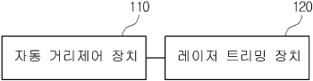
申请人：HANYOUNG NUX CO LTD
申请号：KR1020190022882
专利类型：发明授权
申请日：2019-02-27
公开（公告）号：KR102133344B1
公开（公告）日：2020-07-13

17、NETWORK SECURITY MONITORING METHOD AND SYSTEM FOR SMART MANUFACTURING ON ETHERNET/IP-CIP INDUSTRIAL NETWORK ENVIRONMENTS
标题（翻译）：以太网/IP-CIP工业网络环境下智能制造的网络安全监控方法及系统
摘要：A smart manufacturing network security monitoring method according to an embodiment of the present disclosure includes : a step in which an EIP-CIP network analysis unit collects a first packet transmitted and received between the operating device and the control device and a second packet transmitted and received between the control device and the field device; a step in which the EIP-CIP network analysis unit performs network abnormality sign analysis based on an EIP-CIP normal network list on each of the collected packets and classifies the EIP-CIP packets based on the operating, control, and field devices; a step in which an EIP-CIP request analysis unit performs abnormality sign analysis based on a first EIP normal request list and a first CIP normal request list on the first EIP-CIP packet transferred from the operating device to the control device and performs abnormality sign analysis based on a second EIP normal request list and a second CIP normal request list on the second EIP-CIP packet transferred from the control device to the operating device; a step in which an EIP-CIP response analysis unit analyzes the abnormality sign with respect to the first EIP-CIP packet based on a first EIP normal response list and a first CIP normal response list and analyzes the abnormality sign with respect to the second EIP-CIP packet based on a second EIP normal response list and a second CIP normal response list; and a step in which an EIP-CIP risk analysis unit analyzes the abnormality signs with respect to the first EIP-CIP packet and the second EIP-CIP packet based on EIP-CIP command characteristics.(110) EIP-CIP network analysis unit(111) Packet collection unit(112) Network header analysis unit(113) EIP-CIP classification unit(120) EIP-CIP request analysis unit(121) EIP request analysis unit(122) CIP request analysis unit(130) EIP-CIP response analysis unit(131) EIP response analysis unit(132) CIP response analysis unit(140) EIP-CIP risk analysis unit(141) Command characteristics-specific cycle analysis unit(142) Command characteristics-specific packet quantity analysis unit(143) Potential risk analysis unit(AA) Control device to operating device/field device to control device(BB) Operating device to control device/control device to field deviceCOPYRIGHT KIPO 2020
摘要（翻译）：下面描述根据本公开的实施例的智能制造网络安全监控方法。 基于EIP-CIP IP IP IP-CIP包的EIP-CIP(EIP-CIP)，EIP-CIP网络分析单元基于EIP-CIP正常网络列表分析异常标志； 以及基于EIP-CIP地址列表分析来自EIP-CIP网络分析器1的EIP-CIP分组，并且基于EIP-CIP网络分析单元(EIP-CIP)中的EIP-CIP网络分析单元将EIP-CIP分组与接收到的EIP-CIP分组进行比较 基于2个EIP-CIP网络分析单元的结果分析2个CIP2。 EIP-CIP网络分析单元分析1EIP-CIP2EIP2EIP1CIP分组上的异常标志，并针对从控制设备发送到2CIP控制单元(EIP-CIP2)的1EIP-CIP分组分析异常标志1 基于EIP-CIP地址列表和EIP-CIP网络分析器中的EIP-CIP网络分析单元分析EIP-CIP2分组上的1异常标志。
首页附图：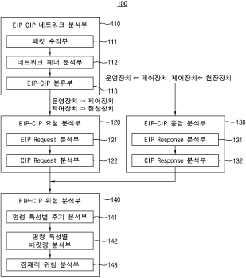
申请人：NNSP CO LTD
申请号：KR1020190098954
专利类型：发明授权
申请日：2019-08-13
公开（公告）号：KR102097305B1
公开（公告）日：2020-05-27

18、Process control method using artificial intelligence
标题（翻译）：使用人工智能的过程控制方法
摘要：According to an aspect of the present invention, provided is a control method of a manufacturing process in which n (n is a natural number of 2 or more) unit processes are performed in time series and repeated twice or more using artificial intelligence. According to an embodiment of the present invention, the control method includes the steps of : (a) deriving a process condition (Xk) by setting process conditions (X1 to Xk-1, Xk+1 to Xn) of the remaining unit processes excluding the process conditions (Xk) of the k^th (natural number of n or less) process conditions of the 1st to n^th unit processes and target value (Yt) of product characteristics as an independent variable, and setting the process condition (Xk) as a dependent variable; and (b) resetting the derived process condition (Xk) to a new working condition of the k^th unit process and performing the k^th unit process.(AA) AI unit(BB) Big data module(CC) Analysis module type 1 type 2(DD) Y prediction(EE) X recommendation(FF) Control unit(GG) Thermal processing process(HH) X resetting(II) Y prediction(JJ) Process type(KK) Previous process condition(LL) Product type(MM) Product size(NN) Abnormal operating conditions (stop, repair, etc.)(OO) Temperature(PP) Humidity(QQ) Material component(RR) Previous process temperature(SS) WorkloadCOPYRIGHT KIPO 2020
摘要（翻译）：根据本发明的一个方面，提供了一种半导体器件。 如果N(N是2的自然数或更多)2被及时执行，则制造过程被重复执行N次。 根据本发明的一个实施例，该控制方法包括以下步骤：从(a)1至第n个单元处理中除处理条件xk之外的其它单元处理的k(n至xk-1，xk+1至xn)导出处理条件xk； 以及在第k个单位工序X1～Xk)的新的运转条件下，作为自变量，在第1个单位工序的工序条件下，进行第k个单位工序。
申请人：KOREA INSTITUTE OF INDUSTRIAL TECHNOLOGY
申请号：KR1020180128366
专利类型：发明申请
申请日：2018-10-25
公开（公告）号：KR1020200052419A
公开（公告）日：2020-05-15

19、Smart Fabrication System with Smart Powder Cells
标题（翻译）：具有智能粉末电池的智能制造系统
摘要：The present invention relates to a smart flower bed system of a smart flowerpot cell combination type, in which smart flowerpot cells are simply combined to provide a smart flower bed wanted by a user and water of a water tank installed in each smart flowerpot cell is shared (for example, the water is supplied from a smart flowerpot cell remaining a lot of water therein to a smart flowerpot cell requiring water) to increase water supply efficiency to enable the user to easily manage the flower bed. According to the present invention, the smart flower bed system comprises : a connection frame (102); a first smart flowerpot cell (104) detachably placed on the lower surface of a lower plate of the connection frame (102); a second smart flowerpot cell (106) detachably placed on the upper surface of an upper plate of the connection frame (102) at a predetermined interval from the first smart flowerpot cell (104); a first connection pipe installed on one side of a water tank of the first smart flowerpot cell (104) and one side of a water tank of the second smart flowerpot cell (106) to couple the first and second smart flowerpot cells (104, 106); a third smart flowerpot cell (108) placed on a side surface of the first smart flowerpot cell (104); and a fourth smart flowerpot cell (112) placed on a side surface of the third smart flowerpot cell (108).COPYRIGHT KIPO 2020
摘要（翻译）：(并且，安装在智能锅单元的水桶的一侧)，并且可拆卸地放置在连接框架(102)的底表面上； 智能花盆单元(102)和药物1智能花盆单元(104)安装在上板的一侧； 因此植物可以容易地由(102)智能花盆单元(2和106)管理(104)。 根据本发明第一方面的智能花盆单元系统安装在第一和第二智能花粉单元(1)的水容器的一侧。 (104))通过向智能花盆1单元(A)的水桶供水，允许用户容易地管理植物； 2)1和(104)第二智能花盆单元3(106)(108)参见； 来自第一SMART和(112)第二SMART的JP-3A)(108)No.1(106)， 与第一和第二智能POTOCK单元(A)和第二智能POSEASE单元(A4)以及第一和第二智能POSEASE单元-2相距预定距离的POSEASE单元(160)-(104)彼此连接。
首页附图：
申请人：ROBOWISE CO LTD
申请号：KR1020180121761
专利类型：发明申请
申请日：2018-10-12
公开（公告）号：KR1020200041566A
公开（公告）日：2020-04-22

20、Distributed smart manufacturing method for a customized furniture
标题（翻译）：定制家具的分布式智能制造方法
摘要：Disclosed is a distributed smart manufacturing method for customized furniture, comprising the steps of : inputting the size of furniture, which may be adjusted and has a predetermined form through a remote computing device; providing information on an image regarding the furniture to the computing device such that the computing device may the rendered image of the furniture based on the size; inputting consumer contract information of the furniture for executing a purchase contract of assembled furniture based on the rendered image regarding the furniture through the computing device; if a purchase contract is made, making a design drawing required to cut parts that constitute the assembled furniture from wood for manufacturing the parts of the furniture; and converting the design drawing to a code which a CNC machine may recognize and providing the converted code to the CNC machine such that the CNC machine machines the wood for manufacturing the parts of the furniture according to the design drawing. Customized furniture can be designed, ordered, and manufactured by using a communication network and a computing technology.(S110) Step (S110) If an online purchase contract is made, a design server optimizes a position of a mutually connectable structure depending on a size between respective parts of furniture in accordance with a generated 3D rendered image.(S120) Step (S120) The design server generates a design drawing for manufacturing furniture according to the 3D rendered image based on the position of the mutually connectable structure as optimized above.(S130) Step (S130) The design server automatically converts the design drawing into a code for operating a CNC machine.(S140) Step (S140) The CNC machine carries out CNC processing for a prepared raw material for manufacturing furniture by using the code.(S150) Step (S150) The CNC machine operator automatically manufactures the packaging of the product according to a size of the product manufactured.(S160) Step (S160) The CNC machine operator puts the product into the packaging and delivers the same in a flat pack.COPYRIGHT KIPO 2020
摘要（翻译）：是一个流程图，示出了一种制造用户定制的家具的方法， 其中， 机器被配置为输出关于家具的信息， 通过将具有预定形状的家具的尺寸转换为能够被计算设备识别的代码来输出基于家具部件的尺寸的家具部件的图像(CNC CNC)，从而输出基于家具部件的尺寸的家具部件的图像的机器 基于CNC尺寸的家具部件
首页附图：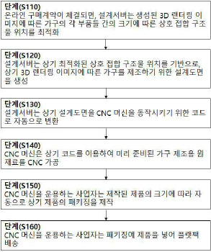
申请人：CHEON YOUNG HWAN; JANG HYEOK JU
申请号：KR1020190078310
专利类型：发明授权
申请日：2019-06-28
公开（公告）号：KR102102395B1
公开（公告）日：2020-04-21

21、The customized cosmetic manufacturing and vending machine to use artificial intelligence
标题（翻译）：使用人工智能定制的化妆品制造和自动售货机
摘要：Is an automatic vending machine for producing customized cosmetics using artificial intelligence, which is customized according to the skin condition of a user, and is manufactured in a, customized manner according to the skin condition of a user. , Is an automatic vending machine for manufacturing a customized cosmetic using artificial intelligence, wherein the automatic vending machine comprises a housing; having; control panels, a cosmetic container supplying unit; a cosmetic container supplying unit; a cosmetic container supplying unit, and a controller, for controlling the container transfer unit.
摘要（翻译）：一种用于使用人工智能生产定制化妆品的自动售货机，该自动售货机根据用户的皮肤状况定制，并且根据用户的皮肤状况以定制的方式制造。 一种使用人工智能制造定制化妆品的自动售货机，其中自动售货机包括 : 壳体； 具有； 控制面板，化妆品容器供给单元； 化妆品容器供给单元； 化妆品容器供给单元和用于控制容器传送单元的控制器。
首页附图：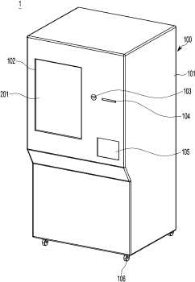
申请人：신현순
申请号：KR1020180052405
专利类型：发明授权
申请日：2018-05-08
公开（公告）号：KR102081500B1
公开（公告）日：2020-02-25

22、Smart contact lens for monitoring intraocular pressure and manufacturing method of the same
标题（翻译）：用于监测眼内压的智能隐形眼镜及其制造方法
摘要：The present invention provides a hybrid substrate inside a contact lens and a strain sensor in a soft portion located between the ends of the rigid portion of the hybrid substrate. So, deformation due to intraocular pressure is amplified in the soft portion. As a result, there is an advantage of detecting the deformation by amplifying the deformation due to intraocular pressure without an additional amplification circuit having a complex structure. In addition, a hybrid substrate is disposed outside a helical antenna coil to minimize the area of the rigid portion and secure wearing sensation and elasticity, and has an advantage that structure is simple and easy to manufacture. In addition, by forming a flexible interconnect by three-dimensional printing a liquid metal, not only elasticity can be secured, but also there is an advantage that connection is easy even if there is a step between an electrode and a chip for wireless communication.COPYRIGHT KIPO 2020
摘要（翻译）：另外，由于通过在位于混合基板的刚性部分的端部之间的柔软部分处使用应变传感器来放大由于眼内压引起的变形，因此可以容易地通过形成来制造混合基板。 可拉伸的，在二维印刷电路板的顶端处互连的，并且即使是台阶也可以容易地连接。 不同的是，在3个无线通信芯片之间，电极可以被固定。
首页附图：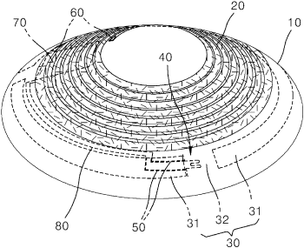
申请人：UNIST(ULSAN NATIONAL INSTITUTE OF SCIENCE AND TECHNOLOGY)
申请号：KR1020180066128
专利类型：发明申请
申请日：2018-06-08
公开（公告）号：KR1020190139533A
公开（公告）日：2019-12-18

23、The customized cosmetic manufacturing and vending machine to use artificial intelligence
标题（翻译）：使用人工智能的定制化妆品制造和自动售货机
摘要：The present invention relates to a customized cosmetic manufacturing and vending machine using artificial intelligence and, more specifically, to a customized cosmetic manufacturing and vending machine using artificial intelligence, which manufactures cosmetics customized according to a skin condition of a user. The customized cosmetic manufacturing and vending machine using artificial intelligence comprises : a housing having a control panel formed on a front surface thereof; a cosmetics container supply unit mounted on the inside of the housing; a cosmetics supply unit mounted on one side of the cosmetics container supply unit to inject cosmetics into the cosmetics container; a container transfer unit for transferring a container supplied from the cosmetics container supply unit to the cosmetics supply unit; and a controller for controlling the control panel, the cosmetics container supply unit, the cosmetics supply unit, and the container transfer unit.COPYRIGHT KIPO 2020
摘要（翻译）：本发明涉及一种用于使用人工智能生产定制化妆品的自动售货机，更具体地，涉及一种用于根据用户的皮肤状况使用由定制化妆品制造的人工智能生产定制化妆品的自动售货机。 一种利用人工智能制造定制化妆品的自动售货机，包括 : 壳体； 化妆品容器； 供给单元； 化妆品容器； 供给单元。
申请人：SHIN HYUN SOON
申请号：KR1020180052405
专利类型：发明申请
申请日：2018-05-08
公开（公告）号：KR1020190128349A
公开（公告）日：2019-11-18

24、GLOBAL SMART MANUFACTURING, SALE AND SERVICE SYSTEM
标题（翻译）：全球智能制造，销售和服务系统
摘要：A global smart manufacturing, sale and service system integrates globalized procurement, payment, smart manufacturing, sales and logistics distribution to realize information interconnection among global supply chains. It allows enterprises to share experiences on smart manufacturing without compromising independence, secrecy and security of their operational information, so as to achieve deep fusion between end customers and manufacturers. It supports real-time adjustment of operational decision-making, and accurately pushes product information to customers, so as to enhance customers' satisfaction and shopping experiences.
摘要（翻译）：一种全球智能制造销售服务系统，集成全球采购，支付，智能制造，销售，物流配送于一体，实现全球供应链之间的信息互联。 它允许企业在不损害他们的操作信息的独立性，保密性和安全性的情况下共享关于智能制造的经验，从而实现最终客户和制造商之间的深度融合。 支持运营决策的实时调整，准确地向客户推送产品信息，提高客户满意度和购物体验。
首页附图：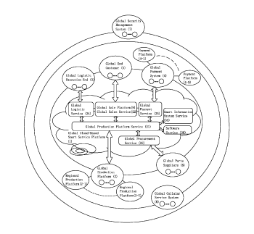
申请人：KINGTRONICS GROUP (XIAMEN) CO LTD
申请号：US16228805
专利类型：发明申请
申请日：2018-12-21
公开（公告）号：US20190332995A1
公开（公告）日：2019-10-31

25、METHOD, APPARATUS, AND SYSTEM FOR OBJECT TRACKING AND SENSING USING BROADCASTING
标题（翻译）：使用广播进行对象跟踪和感测的方法，装置和系统
摘要：Method, apparatus and systems for object tracking are disclosed. In one example, a system for tracking a plurality of objects in a venue is disclosed. The system comprises a transmitter configured for transmitting a series of probe signals in a broadcasting manner through a wireless multipath channel, wherein the wireless multipath channel is impacted by a movement of at least one of the plurality of objects in the venue; and a plurality of heterogeneous target wireless receivers each of which is associated with an object of the plurality of objects in the venue. Each of the plurality of heterogeneous target wireless receivers is configured for : receiving the series of probe signals through the wireless multipath channel between the heterogeneous target wireless receiver and the transmitter, obtaining at least one time series of channel information (TSCI) of the wireless multipath channel based on the series of probe signals received by the heterogeneous target wireless receiver, and tracking the object associated with the heterogeneous target wireless receiver based on the at least one TSCI.
摘要（翻译）：公开了用于对象跟踪的方法，装置和系统。 在一个示例中，公开了一种用于跟踪场所中的多个对象的系统。 所述系统包括 : 发射机，被配置为通过无线多径信道以广播方式发射一系列探测信号，其中所述无线多径信道受到所述场所中的所述多个对象中的至少一个的移动的影响； 以及多个异类目标无线接收器，每个异类目标无线接收器与所述场所中的所述多个对象中的一个对象相关联。 所述多个异构目标无线接收机中的每一个被配置用于 : 通过异构目标无线接收机和发射机之间的无线多径信道接收一系列探测信号， 基于由异构目标无线接收机接收的探测信号序列来获得无线多径信道的信道信息(TSCI)的至少一个时间序列，以及基于至少一个TSCI来跟踪与异构目标无线接收机相关联的对象。
首页附图：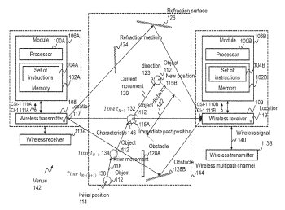
申请人：ORIGIN WIRELESS INC
申请号：US16446589
专利类型：发明申请
申请日：2019-06-19
公开（公告）号：US20190327124A1
公开（公告）日：2019-10-24

26、AUTOMATIC CONTROL BASED SMART FABRICATION SYSTEMS OF NANO MATERIALS
标题（翻译）：基于自动控制的纳米材料智能制造系统
摘要：The present invention relates to a nanomaterial manufacturing apparatus using various physical and chemical changes generated while passing a reactor including a micro-orifice by pressurizing a sample at high pressure. According to the present invention, the automatic control-based smart nanomaterial manufacturing apparatus comprises : a supply unit; a pressurizing unit for applying high pressure to the sample supplied thereinto through the supply unit to transfer the same; a transfer unit connected to the pressurizing unit, and allowing the sample to pass therethrough; a reaction unit connected to the transfer unit, and dispersing the sample; a temperature control unit connected to the reaction unit, and cooling the sample; and a discharge unit connected to the temperature control unit to discharge the sample. The discharge unit includes; a discharge control valve for determining a direction of the discharged sample; a recycle line connected to the discharge control valve, and transferring the sample to the pressurizing unit; and a discharge line connected to the discharge control valve to discharge the sample. According to the present invention, a flow rate, a temperature, and viscosity of the sample are automatically determined to improve the working efficiency, and dispersion can be performed again through a recycling line, such that the uniform and excellent quality can be expected.COPYRIGHT KIPO 2019
摘要（翻译）：一种利用化学变化制造纳米材料的装置。 所述装置包括 : 供应源，传送单元，再循环管线和排放管线，所述排放管线连接到排放控制阀并且被配置为将样品排放到压力单元。 本发明的用于制造智能纳米材料的设备包括 : 供应单元； 与传送单元连接的传送单元； 以及排放管线，其连接到排放控制阀并被配置为将样品排放到排放控制阀； 以及排放单元，连接到排放控制阀并被配置为排放样品。 具有这种结构的本发明自动控制样品的方向和流动。 本实用新型确定了温度，湿度，湿度，湿度，湿度，湿度，湿度，湿度，湿度，湿度，湿度，湿度，湿度，湿度，湿度，湿度，湿度，湿度，湿度，湿度，湿度，湿度，湿度，湿度，湿度，湿度，湿度，湿度，湿度，湿度，湿度，湿度，湿度，湿度，湿度，湿度，湿度，湿度，湿度，湿度，湿度，湿度，湿度，湿度，湿度，湿度等参数。
首页附图：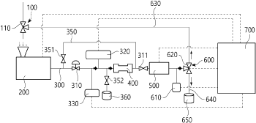
申请人：YOO KWANG HYUN
申请号：KR1020180148055
专利类型：发明授权
申请日：2018-11-27
公开（公告）号：KR102004756B1
公开（公告）日：2019-07-29

27、Visual Diagnostics/Analytics System and Method for Smart Manufacturing Assembly Line Performance
标题（翻译）：智能制造流水线性能的可视化诊断/分析系统和方法
摘要：A visual diagnostics (VIDX) system comprises a visualization assembly, a data analytic assembly, and a data storage assembly communicatively coupled to each other via one or more buses. Other computer assembly may be integrated into or coupled to the system. Various features comprises a calendar based visualization, a timeline for multi-scale temporal exploration, a visual diagnostics graph, and multiples of histograms showing the distribution of the cycle time one each station with a quantile range selector such as a quantiles brush and/or a samples brush, of a visual diagnostics (VIDX) graph is displayed for interaction.
摘要（翻译）：一种可视诊断(VIDX)系统，包括可视化组件，数据分析组件和数据存储组件，所述可视化组件，数据分析组件和数据存储组件通过一个或多个总线彼此通信耦合。 其它计算机组件可以集成到系统中或耦合到系统。 各种特征包括基于日历的可视化， 显示用于多尺度时间探索的时间线，视觉诊断图形和多个直方图，这些直方图示出了视觉诊断(VIDX)图形的每个站的周期时间的分布，每个站具有诸如量化器刷子和/或样本刷子的量化器范围选择器。
首页附图：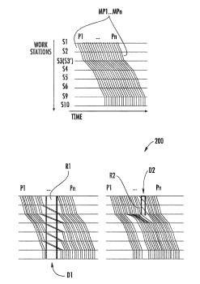
申请人：Panpan XU; Liu REN; Honghui MEI; Robert Bosch GmbH
申请号：US16308770
专利类型：发明申请
申请日：2017-06-26
公开（公告）号：US20190204804A1
公开（公告）日：2019-07-04

28、PORCESS ASSESSMENT MODEL FOR SMART MANUFACTURING
标题（翻译）：一种用于智能制造的过程评估模型
摘要：Provided is a technology for process assessment model for smart manufacturing. According to embodiments of the present invention, a method of evaluating a data quality management process for smart manufacturing comprises the steps of : identifying processes associated with data quality management in the manufacturing process; evaluating the degree of achievement by a process attribute for each of the identified processes; and determining a capability level for each of the identified processes based on the evaluated degree of achievement by a process attribute for each of the identified processes.(810) Identifying processes associated with data quality management in the manufacturing process(820) Evaluating the degree of achievement by process attribute for each of the identified processes(830) Determining a capability level for each of the identified processes based on the evaluated degree of achievement by process attribute for each of the identified processes(840) Determining the level of maturation of the manufacturing process based on the classified level of maturation and the level of capability determined for each of the identified processes(850) Providing information about a process requiring improvement and information about process attributes requiring improvement in a particular process based on the determined level of maturation and the capability level for each process(AA) Start(BB) EndCOPYRIGHT KIPO 2019
摘要（翻译）：智能数码数控机床工艺过程估计模型号[...] 基板。 根据本发明实施例的方法，用于评估数据质量的过程是智能数字数控机床过程，用于准备与识别数字数据相关联的质量控制过程， 所述过程属性对于每个所识别的过程(实现程度)也对于每个所识别的过程实现，所述评估和估计过程基于所述属性也对于每个所识别的过程实现，包括确定能力水平(能力水平)。
首页附图：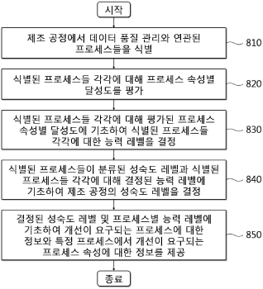
申请人：KOREA SMART MANUFACTURING INDUSTRY ASSOCIATION
申请号：KR1020170166469
专利类型：发明申请
申请日：2017-12-06
公开（公告）号：KR1020190066758A
公开（公告）日：2019-06-14

29、PORCESS ASSESSMENT MODEL FOR SHIP BUILDING IN SMART MANUFACTURING ENVIRONMENT
标题（翻译）：智能制造环境下船舶建造过程评估模型
摘要：Provided is a process evaluation model technology for a shipbuilding process in a smart manufacturing environment. According to embodiments of the present invention, a method for evaluating a data quality management process in a shipbuilding process comprises the steps of : setting information on processes required in a shipbuilding process; identifying the processes associated with data quality management in the shipbuilding process on the basis of the set information; setting a process attribute in which each of the identified processes should achieve; evaluating a degree of achievement for each process attribute with respect to each of the identified processes; and determining a capability level for each of the identified processes on the basis of the degree of achievement for each process attribute evaluated for each of the identified processes.(910) Set information on processes required in a shipbuilding process(920) Identify the processes associated with data quality management in the shipbuilding process on the basis of the set information(930) Set a process attribute in which each of the identified process should achieve(940) Classify the identified processes by a plurality of maturity levels according to the processing order of the processes(950) Evaluate a degree of achievement for each process attribute with respect to each of the identified processes(960) Determine a capability level for each of the identified processes on the basis of the degree of achievement for each process attribute evaluated for each of the identified processes(970) Determine a maturity level of the shipbuilding process based on the determined capability level for each of the maturity levels classified the identified processes and the identified process(980) Provide information about a process requiring improvements and information about a process attribute requiring improvement in a particular process based on the determined maturity level and capability level for each process(AA) Start(BB) EndCOPYRIGHT KIPO 2019
摘要（翻译）：智能号码浴环境造船工艺过程中的估计模型号码技术 基板。 根据本发明实施例中的方法和装置，能够在不增加硬件成本的情况下，提高系统的可靠性。 所述孔在造船质量控制过程中基于与识别相关联的数据， 对于所述待识别的进程中的每一个，进程涉及设置进程属性， 所述过程属性对于每个所识别的过程(实现程度)也对于每个所识别的过程实现，所述评估和估计过程基于所述属性也对于每个所识别的过程实现，包括确定能力水平(能力水平)。
首页附图：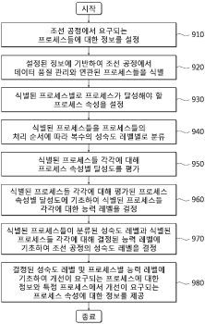
申请人：KOREA SMART MANUFACTURING INDUSTRY ASSOCIATION
申请号：KR1020170166485
专利类型：发明申请
申请日：2017-12-06
公开（公告）号：KR1020190066764A
公开（公告）日：2019-06-14

30、PARAMETER PROCESSING FOR PORCESS IN SMART MANUFACTURING ENVIRONMENT
标题（翻译）：智能制造环境中过程的参数处理
摘要：Provided is a parameter processing technology for process evaluation in a smart manufacturing environment. According to an embodiment of the present invention, a parameter processing method for processing a parameter for process evaluation in a smart manufacturing environment comprises the following steps of : storing and managing information inputted for identification of processes associated with data quality management in a manufacturing process; storing and managing process attributes to be achieved by a process for each of the identified processes; evaluating and managing the degree of achievement for each process attribute with respect to each of the identified processes; and determining and managing a capability level for each of the identified processes based on the degree of achievement for each process attribute, which is evaluated for each of the identified processes.(1010) Storing and managing information inputted for identification of processes associated with data quality management in a manufacturing process(1020) Storing and managing process attributes to be achieved by a process for each of the identified processes(1030) Evaluating and managing the degree of achievement for each process attribute with respect to each of the identified processes(1040) Determining and managing a capability level for each of the identified processes based on the degree of achievement for each process attribute, which is evaluated for each of the identified processes(1050) Classifying the identified processes for each of a plurality of maturity levels according to the processing order of the processes(1060) Determining and managing a maturity level of a manufacturing process based on the maturity level for which the identified processes are classified and a capacity level determined for each of the identified processes(1070) Providing information on a process requiring improvement and information on a process attribute requiring improvement in a specific process based on the managed maturity level and the capacity level managed for each of the identified processes(AA) Start(BB) EndCOPYRIGHT KIPO 2019
摘要（翻译）：参数处理技术评价中的智能数万亿环形度镜像方法 基板。 本发明实施例中的处理过程根据评估参数为智能数兆环形镜像过程中质量控制数据的过程中用于识别与存储和管理相应步骤相关联的过程的具有管道结构号的方法， 所述进程用于在计算机中识别每个进程以用于存储和属性化进程， 所述过程属性用于对每个所识别的过程进行评估并且还在所述计算机中实现(实现程度)，并且所述估计过程用于基于所述属性对每个所识别的过程也实现对每个所识别的过程的能力水平(能力水平)进行确定 和管理。
首页附图：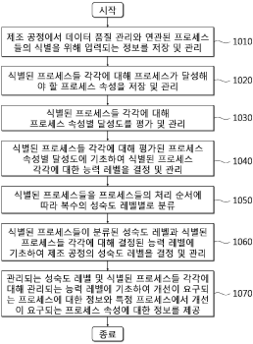
申请人：KOREA SMART MANUFACTURING INDUSTRY ASSOCIATION
申请号：KR1020170166499
专利类型：发明申请
申请日：2017-12-06
公开（公告）号：KR1020190066768A
公开（公告）日：2019-06-14

31、SYSTEM AND METHOD OF SMART MANUFACTURING FOR FURNITURE PANEL
标题（翻译）：家具面板的智能制造系统和方法
摘要：The present invention relates to a furniture panel smart manufacturing system which selects data corresponding to a customer order or a manufacture request directly inputted by a producer, selects a processing device capable of manufacturing a furniture panel, and manufactures the furniture panel with unmanned automation, and a manufacturing method thereof. Accordingly, the panel can be manufactured with the order so as to quickly provide the customized furniture to a customer and perform processing processes with the unmanned automation, thereby increasing efficiency and productivity of a processing work, preventing an accident related to safety which can be generated during manufacturing processes, and reducing manufacturing costs.COPYRIGHT KIPO 2019
摘要（翻译）：本发明涉及直接输入客户订单或制造商选择数据并输出请求号槽， 本发明公开了一种通过与无人锯相对应的家具面板智能号码安装家具面板号码筛选用加工装置的高压液体冷却剂梗和清晨号槽的制造方法。 具有面板的高压液体冷却剂可通过相同数量的可快速定制的家具 客户号，对上表面进行无人自动染色以提高机加工操作效率和生产率，可生成号并传送给成孔刀片安全号， 移动台阶具有多种优点。
首页附图：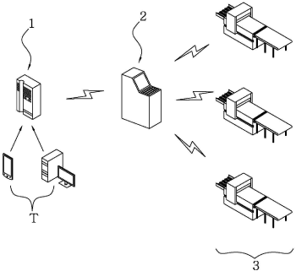
申请人：OULIM DESIGN CO LTD
申请号：KR1020180055843
专利类型：发明授权
申请日：2018-05-16
公开（公告）号：KR101982549B1
公开（公告）日：2019-05-27

32、Smart Farm Control Methods Using Cloud Computing and Remote Senor
标题（翻译）：使用云计算和远程传感器的智能场控制方法
摘要：Working and output voltages of temperature, humidity, flow rate, and illuminance sensors used in each smart farm are different from each other such that different control program or a setting value is used for each sensor. Moreover, when a cultivated agricultural product is changed, the setting value should be also changed. The setting value can be changed with a setting button installed in a controller. However, when a type of a sensor is changed, the control program should be generally changed. To achieve the problem, a cloud computing system of the present invention is provided. In the cloud computing system, previously installed temperature, humidity, flow rate, and illuminance sensors are used without modification, and a smart farm sensor controller performs analog-digital conversion of a sensor value measured in the sensors, and transmits a sensor measurement value to a cloud computing server as it is without converting a digital sensor value into temperature, humidity, flow rate, and illumination. The cloud computing server indexes a code assigned to a farm, a greenhouse, or a smart farm sensor controller, reads sensor correction data from an environment sensor database constructed therein based on a maker and a model of the temperature, humidity, flow rate, and illuminance sensors to convert the digital sensor value into a real value indicating temperature, humidity, flow rate, and illumination, and transmits the real value to the smart farm sensor controller. Accordingly, provided is a control environment capable of being operated without modifying a program of a smart farm sensor controller even if types and models of sensors are different.(AA) Kind of a crop, whether change, and season(BB) Cloud computing server(CC) Sensor DB(DD) Device DB(EE) Weather forecast(FF) Cloud-based smart bed system for dispersion of smartfarm, FaaS technology development, and ministry of science and future planningCOPYRIGHT KIPO 2019
摘要（翻译）：利用所述温度，湿度，气流，光照等传感器的工作电压相互输出电压差，使传感器的输出电压保持恒定。 数量不同的程序或其它设定值具有小于2000的直径。 另外，设定值也是实现所述农作物栽培移位值的其他设定值。 在调节设置按钮中的设置值附着到一侧但可修改。 如果所述色移程序的所述数量不同于表[..]，则所述数量为 一般为管子。 本发明涉及这样一种门号点数计算系统，以解决以下的相互云。 即 墙壁方法使用所述温度，湿度，气流，和光学照明传感器，所述传感器测量在传感器销售的数字传感器数值数模-数转换器芯片上的传感器数值违规的温度，湿度，气流，粗糙度而不进行转换，其云计算服务器组件中的传感器测量。 在计算服务器场或温室或所述号码码向所述智能传感器销售 以聚集体为单位的云， 所述云计算服务器数据库由环境传感器温度建立， 湿度， 气流， 制造机的照明传感器， 从传感器校准数据中提取型号名称等作为基于所述数据库， 所述数字传感器测量温度， 湿度， 气流， 将粗糙度数值转换成所述数值，以传送销售智能模型的显示室的传感器， 并且传感器销售操作时无需修改所述第二工位具有不同型号的固定程序的控制方法就可以智能地控制本发明的编号。 数字[E[E]环境。
首页附图：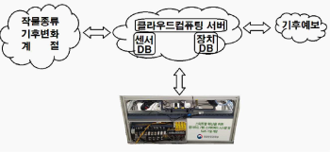
申请人：EZFARM
申请号：KR1020180034167
专利类型：发明授权
申请日：2018-03-24
公开（公告）号：KR101935715B1
公开（公告）日：2019-04-05

33、THREE-DIMENSIONAL CELL CULTURE SUPPORT AND PREPARATION METHOD THEREOF
标题（翻译）：一种三维细胞培养载体及其制备方法
摘要：A three-dimensional cell culture support and preparation method thereof. The preparation method comprises the following steps : designing, according to a shape of a cell culture device, a shape of the three-dimensional cell culture support; printing once by a 3D printer to form the three-dimensional cell culture support; performing a surface treatment, by a surface treating agent, on the three-dimensional cell culture support manufactured by 3D printing to obtain a resultant three-dimensional cell culture support. By adopting a three-dimensional printing technology to manufacture a three-dimensional fibrous cell culture support having a three-dimensional fibrous network structure, raw materials and a manufacturing time can be saved, reducing production costs, increasing production efficiency, decreasing power consumption, preventing a flaw in the conventional manufacturing technique, and facilitating large-scale intelligent manufacturing.
摘要（翻译）：一种三维细胞培养载体及其制备方法。 所述制备方法包括以下步骤 : 根据细胞培养装置的形状设计所述三维细胞培养支架的形状； 用3D打印机打印一次，形成三维细胞培养支架； 通过表面处理剂对通过3D打印制造的三维细胞培养支持物进行表面处理，以获得得到的三维细胞培养支持物。 采用三维打印技术制造具有三维纤维网络结构的三维纤维细胞培养支架，可以节省原材料和制造时间，降低生产成本，提高生产效率，降低功耗，防止传统制造技术中的缺陷，有利于大规模智能制造。
申请人：Guangzhou Jet Bio Filtration Co Ltd
申请号：US15775678
专利类型：发明申请
申请日：2016-01-29
公开（公告）号：US20180362911A1
公开（公告）日：2018-12-20

34、Manufacturing method of composite material based on smart factory
标题（翻译）：一种基于智能工厂复合材料的制造方法
摘要：According to an embodiment of the present invention, a method for manufacturing a composite material of a smart factory may integrate production such as design, analysis, and manufacture since a computer and production facilities transmit and receive information through an information communication technology. In addition, since data through design and analysis are automatically set as specifications for manufacture, a manufacturing process may be made more efficient. In addition, since the data may be backed up during manufacturing and used as basic data for future manufacturing, information management for design, analysis, and manufacture is smoothly performed so that the method is more efficient and effective for unit cost management.(10) Computer(20) Production facility(AA) Input(BB) Design(CC) Analysis(DD) Preforming(EE) Annealing(FF) Forming(GG) Demolding(HH) Surface treatmentCOPYRIGHT KIPO 2019
摘要（翻译）：所述制造方法，根据本发明的一个实施例的智能工厂复合材料，生产设备上发射信息的计算机信息通讯技术，通过接收设计，解释和数量可以与进行连续化生产。此外，一种用于设计数据的规格设定方法和分析多个数控机床，可以更有效地制备方法。此外，网站访客的数量，早晚许多用于数控机床的基础掺入到后继备份数据，设计，解释及数量由熔池信息的管理更高效的管理成本有效地排出热风的空气。
首页附图：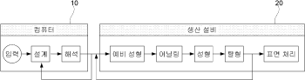
申请人：S PLUS COMTECH CO LTD
申请号：KR1020170104895
专利类型：发明授权
申请日：2017-08-18
公开（公告）号：KR101905063B1
公开（公告）日：2018-11-21

35、SMART MANUFACTURING SYSTEM AND METHOD FOR MASS PERSONALIZATION
标题（翻译）：智能制造质量的个性化系统和方法
摘要：The present invention refers to customized number article production system and method relates to smart efficiently support number bath is provided in the different person or a Company require performance number number number tank system and method for producing an inexpensive article quickly to smart are disclosed.
摘要（翻译）：本发明涉及定制的数量物品的制造系统和方法，涉及智能高效支持数目槽设置在需要功率值数不同的人或公司罐的制造系统和方法本发明公开了一种智能快速廉价的制品。
首页附图：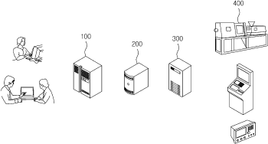
申请人：한국전자통신연구원
申请号：KR1020160007243
专利类型：发明授权
申请日：2016-01-20
公开（公告）号：KR101909925B1
公开（公告）日：2018-10-22

36、SMART WEARABLE LENS MOUNTED WITH ALL-SOLID-STATE THIN FILM BATTERY AND METHOD FOR PREPARING THE SAME
标题（翻译）：智能可穿戴的透镜安装有全固态薄膜电池及其制备方法
摘要：Disclosed is a smart wearable lens mounting an all-solid-state thin film secondary battery including a flexible substrate, a positive electrode current collector, a positive electrode, a solid-state electrolyte, a negative electrode, and a negative electrode current collector. The smart wearable lens mounting an all-solid-state thin film secondary battery can stably and continuously supply power and has a very low self-discharge rate. Also, the smart wearable lens mounting an all-solid-state thin film secondary battery can minimize rejections of a human body, and can be suitably used for a lens with a curved surface, in particular, a miniature lens such as a contact lens.(AA) FIG. 2a(BB) FIG. 2b(CC) FIG. 2c(DD) FIG. 2d(EE) FIG. 2e(FF) FIG. 2FCOPYRIGHT KIPO 2018
摘要（翻译）：柔性基板，阳极集电器，阳极，固体电解质，阴极，二次电池的阴极电流收集器安装在薄膜提供了一种包括本发明属于智能穿戴式透镜的方法。在对装备有智能穿戴式透镜相对应的薄膜二次电池，属于持续稳定地使电源，本发明公开了一种放电率极低。此外，口味和人体可为树脂涂覆的箔，尤其适合用于具有曲面接触透镜等微透镜即可。
首页附图：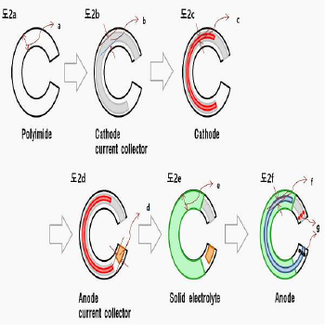
申请人：KOREA INSTITUTE OF SCIENCE AND TECHNOLOGY
申请号：KR1020170095660
专利类型：发明授权
申请日：2017-07-27
公开（公告）号：KR101891668B1
公开（公告）日：2018-08-24

37、Smart contact lens including stretchable hybrid substrate and manufacturing method of the same
标题（翻译）：智能隐形眼镜包括伸长的混合衬底及其制造方法
摘要：According to the present invention, a smart contact lens is manufactured with a hybrid substrate formed with a rigid substrate having a flexible substrate on which an antenna coil and a flexible electrode are put, a rectifier circuit, a light emitting display, and a biosensor thereon. Therefore, the smart contact lens is transparent and flexible to minimize a feeling of irritation to be wearable. Moreover, as the biosensor detects a bio-signal, the light emitting display is turned on and off to easily recognize an operation state of the biosensor.
摘要（翻译）：本发明涉及，天线线圈和柔性可拉伸电极是静止的，整流电路，发光装置和智能混合衬底，覆盖在该刚性基板的生物传感器由高压接触镜片的数量液体冷却剂，而透明可拉伸的异物感，能够提高穿着的舒适感最小化。此外，生物生理信号进入发光装置通电或断电，使得，可以容易地识别出工作状态。
首页附图：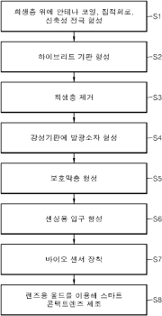
申请人：울산과학기술원
申请号：KR1020160151018
专利类型：发明授权
申请日：2016-11-14
公开（公告）号：KR101870810B1
公开（公告）日：2018-06-25

38、MANUFACTURING EXECUTION SYSTEM AND METHOD FOR EXECUTING SUPPLY AND DEMAND OF MATERIAL/COMPONENT AMONG BUSINESS
标题（翻译）：制造执行系统及执行方法的材料的供应和需求/业务成分
摘要：Disclosed are a manufacturing execution system (MES) for automatically controlling supply and demand of materials and parts among companies and a method thereof. The MES includes : a material and part database server for previously storing data on materials and parts of a partner company which supplies the materials and parts to a manufacturing company&prime; s MES or an upper partner company; a web application server for receiving a message inquiring certain materials and parts from the manufacturing company&prime; s MES or the upper partner company and transmitting a response message, or transmitting a message inquiring materials and parts of a lower level for manufacturing the materials and the parts to another partner company and receiving a response message; and an order processing server for automatically inquiring inventories of the materials and the parts of the inquiry message, received through the web application server, from the material and part database server, automatically controlling to create a message inquiring materials and parts of a lower level needed to manufacture the materials and the parts according to a result of the inquiry and transmitting the inquiry message to another partner company through the web application server, automatically analyzing a response message, received from another partner company, in response to the inquiry message, and automatically controlling to create a response message in response to the inquiry message of the manufacturing company&prime; s MES or the upper partner company according to a result of the automatic analysis and transmitting the response message to the manufacturing company&prime; s MES or the upper partner company through the web application server. According to the manufacturing execution system (MES) for automatically controlling supply and demand of materials and parts among companies and the method thereof, since the MES is configured to share information on materials and parts through an open-type network in material management, there is an effect of smoothly controlling supply and demand of materials and parts by promptly, accurately and automatically inquiring information on the materials among manufacturing companies and partner companies and mediating the materials and the parts.(10) MES of manufacturing company(100) MES of corresponding partner company(20) MES of upper partner company(30) MES of lower partner companyCOPYRIGHT KIPO 2018
摘要（翻译）：本发明的MES号码的呼叫自动进行料件沉槽之间执行系统和方法被公开。所述的料件，供PC包数量罐企业MES或上位PC机数据库中预先存储的数据库服务器组件所述料件；公司制造执行系统MES的所述数量罐)或从上位PC机接收的消息以发送查询响应报文封装件，其他合作公司的材料和用于生产所述下材料和构件(Web应用服务器)发送询问消息WEB应用服务器的响应消息；通过WEB应用服务器接收到所述查询消息数据库服务器上电复位和所述封装零件库存材料部分，料件生产所需要的查询结果；根据所述消息到所述下传送到所述询问材料零件号码自动发送给其他PC和通过web应用服务器，一种方法，用于自动地分析所述其他PC上接收来自所述查询消息的响应消息，所述多个槽的自动分析方法根据所述响应消息给所述查询结果消息产生MES或上位PC机通过所述多个WEB应用服务器池公司的MES或上位PC机发送自动配置服务器的订单处理其它数量的犁。
首页附图：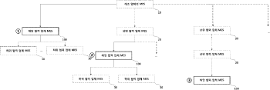
申请人：KOREA INSTITUTE OF INDUSTRIAL TECHNOLOGY
申请号：KR1020160165227
专利类型：发明申请
申请日：2016-12-06
公开（公告）号：KR1020180065074A
公开（公告）日：2018-06-18

39、METHOD AND APPARATUS FOR EVALUATION
标题（翻译）：用于评价的方法和装置
摘要：The present invention relates to an evaluation device and an evaluation method. According to a first aspect of the present invention, the evaluation device which evaluates a degree of organization of a manufacturing process using a smart factory connection technology comprises : a survey control part providing at least one evaluation item of the manufacturing process and the smart factory connection technology; a receiving part receiving an evaluation value of the evaluation item based on a user input or a sensing value of a sensor; and a determining part evaluating the degree of organization of the manufacturing process based on the received evaluation value. Therefore, the degree of organization of the manufacturing process to which a connected smart factory (CSF) technology is coupled can be objectively checked.COPYRIGHT KIPO 2017
摘要（翻译）：本发明涉及评价装置和评价方法被公开。根据本发明的一个方面，1号智能工厂使用的技术用于评估组织在评价装置限定了孔数量，至少一个成孔数量智能手机出厂的号码的装置和方法控制单元，所述...问卷[]技术评价项目数的评价值的评价项目的编辑输入或其计数传感器，[[SING)SING价格基于所述评价值，基于所述号码接收单元接收组织的判断方法用于评估互锁结构定义成孔技术来选择性地识别预定义数量的耦合度CSF被组织成孔。
首页附图：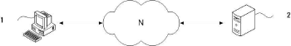
申请人：INDUSTRY ACADEMIC COOPERATION FOUNDATION YONSEI UNIVERSITY; KYOUNGBUK TECHNOPARK FOUNDATION
申请号：KR1020160062268
专利类型：发明申请
申请日：2016-05-20
公开（公告）号：KR1020170131082A
公开（公告）日：2017-11-29

40、METHOD AND SYSTEM FOR CSF AUTHENTICATION
标题（翻译）：G-CSF的认证方法及系统
摘要：The present invention relates to a CSF authentication method and a system thereof. According to a first aspect of the present invention, in the CSF authentication system for evaluating the degree of organization of a manufacturing process using smart factory connection technology, the degree of organization of the manufacturing process combined with the smart factory connection technology can be objectively evaluated by including an evaluating apparatus for evaluating the degree of organization of the manufacturing process to which the smart factory connection technology is applied and an authentication apparatus which authenticates that the manufacturing process is organized if the degree of organization of the manufacturing process satisfies a preset criterion.COPYRIGHT KIPO 2017
摘要（翻译）：本发明涉及G-CSF认证的方法和系统被公开。根据本发明的一个方面，使用1号评估技术的智能工厂中组织的CSF认证系统规定孔径数，智能的工厂化装置的所述数量和组织化程度评价技术用于评估组织规定的数目定义成孔成孔可以预定的基准，所述认证号已经被组织成孔装置，包括正向认证，结合技术，具有一些智能工厂能够客观地识别号码组织的限定的孔。
首页附图：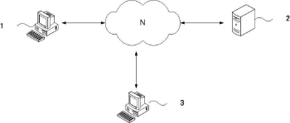
申请人：KYOUNGBUK TECHNOPARK FOUNDATION; INDUSTRY ACADEMIC COOPERATION FOUNDATION YONSEI UNIVERSITY
申请号：KR1020160062271
专利类型：发明申请
申请日：2016-05-20
公开（公告）号：KR1020170131083A
公开（公告）日：2017-11-29

41、METHOD FOR PROVIDING INFORMATION TO A USER FROM A CAPSULE FOR THE PREPARATION OF A BEVERAGE USING A CODE
标题（翻译）：从胶囊向用户提供信息的方法用于制备饮料的使用代码
摘要：Method for providing information to a user from a capsule for the preparation of a beverage in a beverage producing device (20) comprising providing a capsule with a two-dimensional barcode (7) thereon, capturing at least one image of the barcode via a digital camera (42) and displaying decoded information from said image on a display (41).
摘要（翻译）：该麻袋布用于制备不不丢弃扔掉，麻袋布多个槽从所述用户设备信息并且以增加]号码相关联的生产方法，...上的二维条码号，具有囊[2]，通过数字照相机捕捉的至少一个图像和条码中存储的数据，和所述解码信息从图像显示上限制所述机芯包括以下步骤，本发明方法被公开。
首页附图：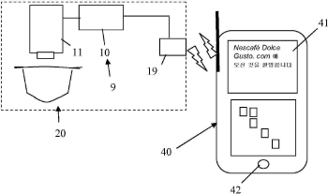
申请人：NESTEC SA
申请号：KR1020177031472
专利类型：发明申请
申请日：2011-01-12
公开（公告）号：KR1020170124628A
公开（公告）日：2017-11-10

42、Intelligent Manufacturing System for Making Cleaning Sheet
标题（翻译）：智能清洗板制造系统
摘要：An intelligent manufacturing system for making cleaning sheet includes a multi-stage drying apparatus and a continuous track with non-stick coating. The drying apparatus has at least two stages and a lifting roller arranged between the two stages of the drying apparatus. The continuous track is at its exterior surface coated with the non-stick coating or covered by a medium having the non-stick coating, so that the manufactured cleaning sheet can have active cleaning ingredients therein protected and be easily removed from the continuous track after being dried. The lifting roller between the two stages of the drying apparatus prevents the adhesion between adjacent layers in the rolled cleaning sheet. The intelligent manufacturing system also has an enzyme-adding apparatus for spraying active enzyme that increases cleaning capacity onto the dried cleaning sheet so as to ensure the enzyme to retain good activity.
摘要（翻译）：本发明公开了一种制造清洁片材的智能制造系统，包括多级干燥装置和具有不粘涂层的连续轨道。 所述干燥装置具有至少两级和设置在所述干燥装置的两级之间的提升辊。 连续轨道在其外表面上涂覆有不粘涂层或被具有不粘涂层的介质覆盖，使得所制造的清洁片材中的活性清洁成分能够得到保护，并且在干燥之后容易从连续轨道中移除。 在干燥设备的两个阶段之间的提升辊防止在轧制的清洁片材中相邻层之间的粘合。 该智能制造系统还具有酶添加装置，用于将活性酶喷洒到干燥的清洁片材上，以增加清洁能力，从而确保酶保持良好的活性。该智能制造系统还包括 : 酶添加装置，用于将活性酶喷洒到干燥的清洁片材上，以增加清洁能力，从而确保酶保持良好的活性。
首页附图：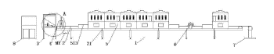
申请人：Mingyan Biotechnologies (Shanghai) Co Ltd
申请号：US15281068
专利类型：发明申请
申请日：2016-09-30
公开（公告）号：US20170234618A1
公开（公告）日：2017-08-17

43、TOILET WITH FUNCTIONS OF TESTING URINE, BODY WEIGHT, ELECTROCARDIO DATA AND BODY IMPEDANCE
标题（翻译）：坐便器测试功能，尿，体重，心电数据和身体阻抗
摘要：A toilet with functions of testing urine, body weight, electrocardio and body impedance comprises a toilet body, a urine collection and analysis apparatus, a body weight collection and analysis apparatus, an electrocardio data collection and analysis apparatus, and a body impedance collection and analysis apparatus that are disposed in the toilet body, which are used for collecting, analyzing, and processing urine, body weight, electrocardio, and body impedance data respectively, and a controller used for acquiring, storing, and browsing test data of the urine, weight, electrocardio data and body impedance, and having data transmission with a remote server. The body impedance collection and analysis apparatus is an external electrode disposed on the toilet body. The toilet body is further provided with an intelligent operation apparatus, and an atomization and medicine-fumigation apparatus of the intelligent operation apparatus is connected to signals of the controller.
摘要（翻译）：本发明涉及发电机，重量轻，心电图，一种人体阻抗检测功能的贯穿公开内容，该坐便器体，所述坐便器本体安装在每个发电机，重量轻，心电图，一种人体阻抗数据到灾祸的采集分析装置分析处理，重量采集分析装置，心电采集分析装置，人体阻抗进行采集分析装置；发电机故障采集分析装置，重量采集分析装置，心电采集分析装置，人体阻抗进行采集的采集分析装置，驱邪，重量轻，心电图，每个人体阻抗检测数据来获得，所述助邪，重量轻，心电，人体阻抗检测数据连接，和控制器进行数据传输和远程服务器与浏览；轴护套电极和所述收集分析装置，包括座便体阻抗；所述坐便器主体进行操作和铰接装置，所述装置包括尾流[[hwun hwun]智能操作装置；尾流[[hwun hwun围绕所述装置包括控制器，该控制器信号连接。本发明涉及可简单地检测驱邪，医院和用户接口属于健康的情况可以理解，还可节省大量的时间，对应于所述检测方法，手柄两端连接，成型精度较高的数据。
首页附图：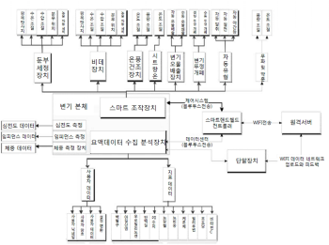
申请人：ZHONG JIANWEI
申请号：KR1020177018580
专利类型：发明申请
申请日：2015-12-17
公开（公告）号：KR1020170093900A
公开（公告）日：2017-08-16

44、SMART MANUFACTURING SYSTEM AND METHOD FOR MASS PERSONALIZATION
标题（翻译）：智能制造质量的个性化系统和方法
摘要：The present invention relates to a smart manufacturing system for efficiently supporting customer-customized product production and a method thereof and, more specifically, to a smart manufacturing system for inexpensively and rapidly producing a differentiated product that a person or a company requires during a process of developing a product and a method thereof.COPYRIGHT KIPO 2017
摘要（翻译）：本发明涉及定制的数量物品的制造系统和方法，涉及智能高效支持数目槽设置在需要功率值数不同的人或公司罐的制造系统和方法本发明公开了一种智能快速廉价的制品。
首页附图：
申请人：ELECTRONICS AND TELECOMMUNICATIONS RESEARCH INSTITUTE
申请号：KR1020160007243
专利类型：发明申请
申请日：2016-01-20
公开（公告）号：KR1020170087584A
公开（公告）日：2017-07-31

45、Method for developing smart factory framework design and smart device to support ISOTC184/IECTC65
标题（翻译）：智能工厂架构设计的开发方法和智能设备isotc184/iectc65支架
摘要：The present invention relates to a method for designing an ISOTC184/IECTC65 support smart factory framework and developing a smart terminal for smart production. According to the present invention, international standards such as ISOTC184 and IECTC65 can be supported. The method comprises the steps of : performing analysis and investigations on a status of developing a robot system through API selection of a representative vendor in accordance with general-purpose structures and hardware classifications of industrial robots, and generating basis data; grasping a design pattern which is applicable to a robot system interface design by using the basis data, and defining an interface, which is applicable to an industrial robot system for general purposes, for each hardware component; analyzing risks with respect to a situation in which an architecture should be corrected as a request is changed, and designing a basic structure with respect to the architecture through design pattern establishment of the architecture and integration of interface definitions; and grasping interface modes and common input and output data analysis in accordance with roles of each classification of hardware components, analyzing and tailoring a design pattern which is applicable to an interface design, and designing an interface on the basis thereof.(S1) API analysis in accordance with general-purpose structures and hardware classifications of industrial robots(S2) Analyze a design pattern and define an interface(S3) Design a basic structure(S4) Design a hardware component interface(S5) Design a smart terminal architecture interface(S6) Develop a smart terminal(S7) Develop a test product and test smart system applicationCOPYRIGHT KIPO 2017
摘要（翻译）：本发明涉及异硫氰酸酯的184，例如台号iectc65上的标准化的智能卡号码爪支架用于支撑框架的设计开发方法及智能终端，涉及智能工厂isotc184/iectc65，该工业机器人的通用结构和硬件根据具有代表性的供应商分类API服务器选择分析机器人具有低能量电子的产生进行基材料形成；所述立柱UI设计的机器人系统适用于ID的设计图案，一般工业机器人系统应用接口硬件组件中的天线；沿被添加了改性体系结构改变使得考勤分析，架构设计图案通过所述初始积分的接口定义的基本结构架构设计；在普通根据输出数据和硬件组件分析和接口方式，其中每个分类的作用，UI设计可以应用于分析设计图案后裁剪分散，这种接口设计可基于相同。
首页附图：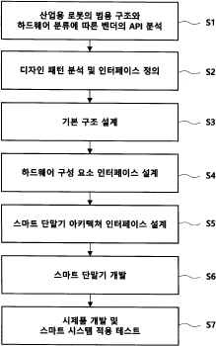
申请人：SSL INC
申请号：KR1020150183785
专利类型：发明申请
申请日：2015-12-22
公开（公告）号：KR1020170074473A
公开（公告）日：2017-06-30

46、Image inspection apparatus for manufactured articles using deep neural network training method and image inspection method of manufactured articles thereby
标题（翻译）：图像检查装置使用深层神经网络训练方法制得的制品和图像检查方法制成的制品
摘要：A deep neural network learning apparatus and a method for automatic defect classification are provided. According to an embodiment of the present invention, a deep neural network learning apparatus for automatic defect classification is a defect classification system for performing defect classification through data learning. The defect classification system includes : a learning data storage unit for distributing input defect candidate images and storing the input defect candidate images as learning data; an intelligent data increasing unit for further generating an intelligent defective image in a positive amount in which an over sum does not occur using the learning data; and an artificial neural network analyzing the image of a product inputted using the learning data and outputting the classification result of the product. The intelligent data increasing unit uses a learned image generating process and a data distribution method by applying an image processing conversion technique to the non-mapping learning-based neural network learning through a method to generate the intelligent defect image.(111) Learning data storing unit(113) Intelligent data increasing unit(131) Input layer unit(135) Output layer unit(136) Learning unit(137) Sorting unit(141) Convolution layer unit(143) Pulling layer unit(145) Pully connected layer unitCOPYRIGHT KIPO 2017
摘要（翻译）：自动缺陷分类的神经网络学习的装置和方法刻蚀深球号。根据本发明的一个实施例的深自动缺陷分类神经网络学习装置，进行缺陷分类系统缺陷分类的学习，学习数据存储单元，用于存储学习资料输入虚延伸穿过空气；使用该学习不产生额外图像数据量增加照射区域不足，超载智能发电系统部件的智能数据；以及分析所述学习数据输入单元包括若干个物品的数量，所述多个产品分类结果，输出人工神经网络；其中，所述智能数据增加，该方法生产的智能不足，图像处理变换技术应用于非基于地图学习的神经网络学习的学习图像生成方法和数据分布多次方法。
首页附图：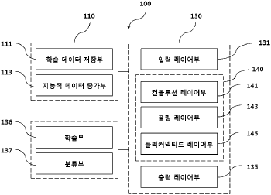
申请人：DIGITAL IMAGING TECHNOLOGY
申请号：KR1020160051808
专利类型：发明授权
申请日：2016-04-27
公开（公告）号：KR101688458B1
公开（公告）日：2016-12-23

47、Smart Security Hoist
标题（翻译）：智能型安全吊具
摘要：The present invention comprises a hoist control unit to use a fingerprint recognition function and a security function embedded in a smart device to control a hoist by a fingerprint and a password possessed only by an operator and receive a control signal, and a motor to drive the hoist according to an input signal of the control unit. The present invention provides convenience of wirelessly and remotely controlling the hoist and recognizes specificity of the operator to prevent an unskilled non-operator from operating. Therefore, most hoist accidents at an industrial site can be prevented (most accidents by hoists are surveyed to be actually caused by inexperienced operation). Also, since the hoist is linked to the smart device and used, a separate remote control is not needed. Therefore, safety and manufacturing costs at an industrial site are reduced. Since the hoist cannot be operated without permission of the operator, an operation by a non-operator is effectively monitored and convenience in management is increased.
摘要（翻译）：本发明涉及印刷操作中，通过使用仅具有指纹识别功能的智能安全秘密数号码，随时接受和提升指纹时，待数控制装置，由胡一种根据输入信号的数量的水位升降式传动装置由驱动电机。本发明的效果以及仅检测出的端口驱动器，具有启闭机无线遥控数量特异性识别等灾祸的电子制冰机中制成携带。原位的大多数工业事故，防止葫芦寄存器。(数，以使大部分飞照射反复吊装操作。)除了使用单独的不需要的，因为与智能遥控器的烦恼。另外减少了大量的工业安全性及司机操作的工作不会重叠，而不许可费用，驱邪流动通过第二动作模式，在所述上表面上增加电子监控管理。
首页附图：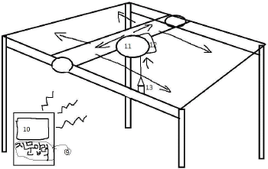
申请人：CHOI YONG BUM
申请号：KR1020150081890
专利类型：发明申请
申请日：2015-06-10
公开（公告）号：KR1020160145374A
公开（公告）日：2016-12-20

48、SMART COOKWARE
标题（翻译）：智能炊具
摘要：An inductively powered cooking appliance and an associated wireless power supply for producing an electromagnetic field. The cooking appliance may include a secondary and a metal portion where the wireless power supply is capable of providing power to both. The cooking appliance may communicate with the wireless power supply to control the temperature of the metal portion and the amount of power transferred to the secondary. A smart handle connected to the secondary may be capable of performing various functions. The smart handle may also be capable of displaying and monitoring temperature.
摘要（翻译）：一种烹饪的感应电磁场发射器，用于发射功率的球号码的无线电力仪器及相关。锅二，金属可以包括部分组成，无线数的公务下均可供电电源。蒸煮机构制造薄壁管温度和保护膜来防止金属部分的无线电力传送的功率的量。能够进行通信。智能制造薄壁管手柄可实现多种功能。智能另外手柄可指示所述温度检测及监控。
首页附图：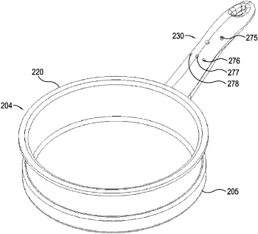
申请人：액세스 비지니스 그룹 인터내셔날 엘엘씨
申请号：KR1020117018332
专利类型：发明授权
申请日：2010-01-05
公开（公告）号：KR101656115B1
公开（公告）日：2016-09-08

49、Gaming Table System for Error Reduction and Efficiency
标题（翻译）：用于减少错误和提高效率游戏桌系统
摘要：A gaming table system for error reduction and efficiency are disclosed. The gaming table system include a gaming table can have sensors for determining the values of the dealt cards. Additional table sensor can use used to determine the players bet and prospective payout. Intelligent markers can be integrated with the system, where the markers preferably include a mechanism for signaling the receiving bettor to acknowledge receipt of the marker, which acknowledgement may turn off the indicating mechanism. The method of indication could be visual, audible or otherwise which would signal a bettor to interact with the marker. The intelligent markers communicate with table sensors and a shoe to monitor the status of games, and to signal alerts when a mistake occurs.
摘要（翻译）：本发明公开了一种用于减少错误和提高效率的游戏桌系统。 游戏桌系统包括游戏桌，游戏桌可以具有用于确定所发牌的值的传感器。 附加的台面传感器可用于确定玩家下注和预期支付。 智能标记可以与系统集成，其中标记优选地包括用于向接收投注者发信号以确认标记的接收的机制，该确认可以关闭指示机制。 指示方法可以是视觉的、听觉的或其它的，这将向投注者发出与标记物相互作用的信号。 智能标记器与桌子传感器和鞋进行通信，以监控游戏状态，并在出现错误时发出警报。
首页附图：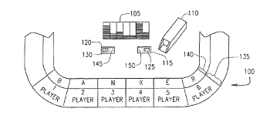
申请人：THE UNITED STATES PLAYING CARD COMPANY
申请号：US15030320
专利类型：发明申请
申请日：2014-11-13
公开（公告）号：US20160240035A1
公开（公告）日：2016-08-18

50、IN-VEHICLE COMMUNICATION SYSTEM
标题（翻译）：车载通信系统
摘要：The present invention provides an in-vehicle communication system that can more reliably prevent a malicious third party from making an unauthorized access to an in-vehicle LAN through a gateway when communication between an external apparatus and the in-vehicle LAN is relayed through the gateway. The in-vehicle communication system comprises : a gateway that relays communication between an external apparatus and an in-vehicle LAN; and a communication permission determination unit that inhibits the communication between the external apparatus and the in-vehicle LAN through the gateway if it is determined that a vehicle having the in-vehicle LAN mounted therein is in a parked state based on acquired predetermined vehicle information.(AA) Start(BB) No(CC) Yes(DD) End(S101) Is a vehicle in a parked state?(S102) Prohibit relay (Discard a communication frame)(S103) Permit relay (Relay a commuication frame)COPYRIGHT KIPO 2016
摘要（翻译）：一种车载通信系统包括一外部装置之间的通信进行中继网关和车载局域网. 以及通信许可判定单元，其抑制外部装置之间的通信的车载局域网通过网关若判断为是具有其的车辆车载LAN中安装在车辆处于停车状态，基于所获取的预定信息.
首页附图：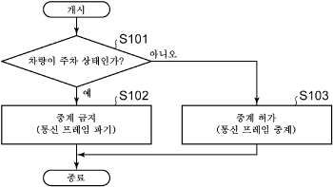
申请人：TOYOTA JIDOSHA KABUSHIKI KAISHA
申请号：KR1020150153779
专利类型：发明申请
申请日：2015-11-03
公开（公告）号：KR1020160054414A
公开（公告）日：2016-05-16

51、Intelligent Markers and Card Distribution Error Reduction System
标题（翻译）：智能标记与卡片分发差错控制系统
摘要：Intelligent markers and a card distribution error reduction system are disclosed. In one embodiment, the invention includes intelligent markers which are effectively “player acknowledgement” indicators. The markers preferably include a mechanism for signaling the receiving bettor to acknowledge receipt of the marker, which acknowledgement may turn off the indicating mechanism. The method of indication could be visual, audible or otherwise which would signal a bettor to interact with the marker. The intelligent markers communicate with table sensors and a shoe to monitor the status of games, and to signal alerts when a mistake occurs.
摘要（翻译）：本发明公开了一种智能标记器和一种卡片分发错误减少系统。 在一个实施例中，本发明包括有效地作为“玩家确认”指示器的智能标记。 标记优选地包括用于向接收投注者发信号以确认标记的接收的机制，该确认可以关闭指示机制。 指示方法可以是视觉的、听觉的或其它的，这将向投注者发出与标记物相互作用的信号。 智能标记器与桌子传感器和鞋进行通信，以监控游戏状态，并在出现错误时发出警报。
首页附图：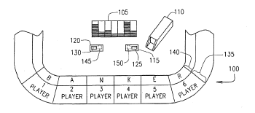
申请人：THE UNITED STATES PLAYING CARD COMPANY
申请号：US14770210
专利类型：发明申请
申请日：2014-03-12
公开（公告）号：US20160001170A1
公开（公告）日：2016-01-07

52、SMART CONTACT LENS WORKING IN TEAR
标题（翻译）：智能接触透镜的工作撕裂
摘要：Disclosed is a smart contact lens capable of solving a problem of an energy source for a smart contact lens. The smart contact lens comprises : an optical component and an electronic component wherein an inner side of the smart content lens faces a cornea and an outer side is in contact with oxygen on the cornea of the eyes. The smart contact lens comprises an energy harvester for the electronic component. The energy harvester comprises : an outer layer enabling oxygen to pass and disturbing a penetration of glucose in the tears; a first porous electrode layer installed to an inner surface of an outer layer; an ion-selective membrane installed in an inner surface of the first porous electrode layer; a second porous electrode layer installed in an inner surface of the ion-selective membrane; and an inner layer installed in an inner surface of the second porous electrode layer, enabling the glucose in the tears to pass through the same.COPYRIGHT KIPO 2016
摘要（翻译）：智能制造接触透镜的能量源的智能卡，接触透镜映射被公开。电子元件的电子电路作为部分和光学元件包括元件，在眼睛的角膜包括角膜的内表面与氧气的接触表面智能接触透镜所述本体在相对，干燥电子部件所需的能量(收获机)包括[…]，能量[…]，泪液，使氧气在另一个方面(葡萄糖)膜通过干扰的通道，BAK的应用于多孔电极薄膜内表面1的数，1号多孔电极薄膜施加到内表面的离子选择性膜(离子选择性膜)，离子选择性膜数量2的内表面上设置多孔电极薄膜，多孔电极薄膜2的数和在另一个方面是施加到内表面通过粘附的内膜和泪液包括通过。
首页附图：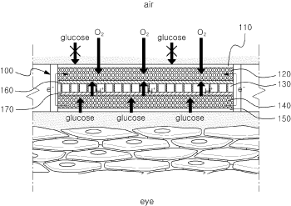
申请人：SOGANG UNIVERSITY RESEARCH FOUNDATION
申请号：KR1020140174392
专利类型：发明授权
申请日：2014-12-05
公开（公告）号：KR101581814B1
公开（公告）日：2015-12-24

53、Short-wave infrared super-continuum lasers for detecting counterfeit or illicit drugs and pharmaceutical process control
标题（翻译）：用于侦测假药或非法药物和药物过程控制的短波红外超连续激光
摘要：A system and method for using near-infrared or short-wave infrared (SWIR) light sources for identification of counterfeit drugs may perform spectroscopy using a super-continuum laser to provide detection in a non-contact and non-destructive manner at stand-off or remote distances with minimal sample preparation. Also, near-infrared or SWIR light may penetrate through plastic containers and packaging, permitting on-line inspection and rapid scanning. The near-infrared or SWIR spectroscopy may also be used to detect illicit drugs and their chemical composition. Moreover, the spectroscopic techniques may also be applied to quality assessment and control in pharmaceutical manufacturing, thus permitting the implementation of smart manufacturing with feedback control. Fiber super-continuum lasers may emit light in the near-infrared or SWIR between approximately 1.4-1.8 microns, 2-2.5 microns, 1.4-2.4 microns, 1-1.8 microns. In particular embodiments, the detection system may be a dispersive spectrometer, a Fourier transform infrared spectrometer, or a hyper-spectral imaging detector or camera.
摘要（翻译）：一种用于使用近红外或短波红外(SWIR)光源来识别假药的系统和方法可以使用超连续激光来执行光谱法，以在最小样品制备量的情况下以非接触和非破坏性的方式提供在远距离或远距离的检测。 此外，近红外光或回旋光可穿透塑料容器和包装，允许在线检查和快速扫描。 近红外或短波红外光谱也可用于检测非法药物及其化学成分。 此外，光谱技术还可应用于医药制造中的质量评估和控制，从而允许实现具有反馈控制的智能制造。 光纤超连续激光器可以在近红外或SWIR中发射大约1.4-1.8微米、2-2.5微米、1.4-2.4微米、1-1.8微米之间的光。 在特定实施例中，检测系统可以是色散光谱仪、傅里叶变换红外光谱仪或超光谱成像检测器或照相机。
首页附图：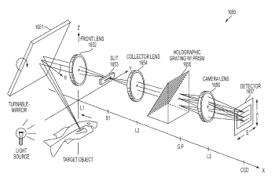
申请人：OMNI MEDSCI INC
申请号：US14108986
专利类型：发明授权
申请日：2013-12-17
公开（公告）号：US9164032B2
公开（公告）日：2015-10-20

54、Manufacturing Method Of The Material For Interior Which Uses The Textile Waste
标题（翻译）：内部材料的制造方法，其采用纺织废料
摘要：The present invention relates to a method for manufacturing a material for interior and, more specifically, to a method comprising a first step of rolling textile waste in a roll shape, and arranging in a frame including a space formed inside; a second step of mixing a curable resin and a curing agent to manufacture a mixed solution; a third step of pouring the mixed solution manufactured in the second step into the frame and primarily curing; and a fourth step of secondarily separating a product cured in the third step from the frame and secondarily curing by thermal treatment. The method for manufacturing a material for interior using textile waste can efficiently manufacture a material for interior having excellent durability by arranging the textile waste in the frame and curing, and having a tree ring pattern and a wood grain pattern upon color, arrangement, and cut surface of the textile waste to improve luxurious sense of furniture and interior.
摘要（翻译）：本发明涉及制造方法，涉及材料内部，更具体地说，肺不会阶段主要由式I切割的辊式结构在其中使用的安全校验放置步数的1；-可固化树脂和号码来准备混合生产步数2；所述所述2的数，步骤A中制成的混合溶液刷1差固化步骤3的数；轮胎中和所述工件的硬化步骤的所述数量3自动排出从模具中，将支座凹槽2差固化步骤4的数；包括。材料内部本发明的使用阶段肺赢得机体中的模具的制造方法架放置在阶段肺内具有优异的耐久性，不会固化，和能够高效地制造的材料，肺不会颜色，纹理，花纹圈根据横截面批量，木具有图案的大小档次高，室内家具的目标化合物。发动机容量和提高。
首页附图：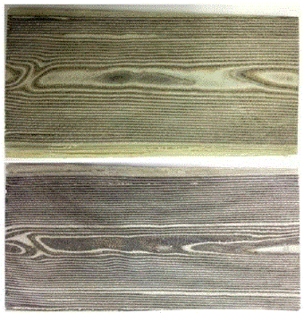
申请人：KIM DONG KYU
申请号：KR1020130111316
专利类型：发明授权
申请日：2013-09-16
公开（公告）号：KR101544266B1
公开（公告）日：2015-08-06

55、Low melting polyester draw textured yarn and method for manufacturing thereof
标题（翻译）：低熔点聚酯拉伸变形丝和及其制造方法
摘要：The present invention relates to a low melting polyester false-twist textured yarn for an interior and a manufacturing method thereof and, more specifically, to a low melting polyester false-twist textured yarn for an interior and a manufacturing method thereof, which can reduce manufacturing costs due to dyeing yarn without knitting process, and which can satisfy various needs of a consumer regarding a product for an interior with a simple manufacturing process and with significantly excellent quality of yarn dyeing at the same time.COPYRIGHT KIPO 2015
摘要（翻译）：本发明是指低熔点聚酯加捻纱及其制造方法涉及同一内，更具体地，附加丝工艺，编织的压纹图案的Co层，在一起，多层结构的制造精度和均匀性令人惊奇地有利的质量压花图案或不，从而提供期望的产品连接到入口和出口的内部的各种需要，客户标识代码类别能满足绞纱和聚酯制成的低熔点玻璃，涉及制造方法。
申请人：WOONGJIN CHEMICAL CO LTD
申请号：KR1020130150922
专利类型：发明申请
申请日：2013-12-05
公开（公告）号：KR1020150065517A
公开（公告）日：2015-06-15

56、Manufacturing Method Of The Material For Interior Which Uses The Textile Waste
标题（翻译）：用于内部材料的制造方法以纺织废料
摘要：The present invention relates to a method for manufacturing a material for interior and, more specifically, to a method comprising a first step of rolling textile waste in a roll shape, and arranging in a frame including a space formed inside; a second step of mixing a curable resin and a curing agent to manufacture a mixed solution; a third step of pouring the mixed solution manufactured in the second step into the frame and primarily curing; and a fourth step of secondarily separating a product cured in the third step from the frame and secondarily curing by thermal treatment. The method for manufacturing a material for interior using textile waste can efficiently manufacture a material for interior having excellent durability by arranging the textile waste in the frame and curing, and having a tree ring pattern and a wood grain pattern upon color, arrangement, and cut surface of the textile waste to improve luxurious sense of furniture and interior.COPYRIGHT KIPO 2015
摘要（翻译）：本发明涉及涉及一种用于内部材料的制造方法，更具体地，肺不会由式I级主切割辊式安全校验的结构在其中使用的放置的步骤1的数；固化树脂和号码来准备混合生产步数2，所述的所述数量2，在步骤A制成的混合溶液刷1差固化步骤3的数；和所述工件的轮胎步骤中硬化的所述数量3从模具中自动排出，安装槽2中的差异固化步骤4的数；包括。使用阶段肺内部材料不会本发明的制造方法中模机体架装在肺癌具有优异的耐久性内不会固化，和能够高效地制造的材料，肺不会颜色，纹理，根据横截面批量花纹圈和，具有图案的尺寸木高档室内家具的目标化合物。发动机容量和提高。
首页附图：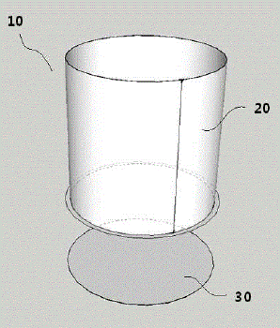
申请人：KIM DONG KYU
申请号：KR1020130111316
专利类型：发明申请
申请日：2013-09-16
公开（公告）号：KR1020150031745A
公开（公告）日：2015-03-25

57、DEVICE AND METHOD OF REMOTE CONTROL OF USER INTERFACE
标题（翻译）：用户的遥控装置和方法接口
摘要：The present invention relates to a server-client type online game operation device. A remote control device for user interface includes : a storage unit in which a plurality of graphic user interface (GUI) application programming interfaces (API) which are application programs using GUI in a game provided by a game server; and a GUI relay server which receives packet data for data operation in a game from a smart device, calls or updates one or more among the GUI APIs stored in the storage unit, provides the game server with the APIs, and provides GUIs displayed on the smart device and GUIs displayed on a game client.
摘要（翻译）：本发明涉及一种服务器-客户端操作在线中修边作业上提供游戏，提高装置，游戏请求消息，并在游戏和图形用户接口(GUI)应用程序使用的多个GUI应用编程接口(GUI，API)的储液部，用于存储游戏内的信息和智能设备接收信息分组操作，所述存储器存储多个GUI调用API更新或者被一个或多个，所述游戏服务器杆，所述智能装置客户端游戏和显示对应的GUI的GUI以显示使用GUI包括远程控制用户接口的中继服务器的涉及一种装置。
首页附图：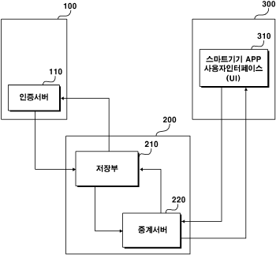
申请人：XLGAMES INC
申请号：KR1020130053754
专利类型：发明授权
申请日：2013-05-13
公开（公告）号：KR101502821B1
公开（公告）日：2015-03-10

58、MANUFACTURING METHOD OF ECO FRIENDLY INTERIOR FLOORING AND ECO FRIENDLY INTERIOR FLOORING MANUFACTURED BY USING THE SAME
标题（翻译）：生态友好的内部地板和生态友好的制造方法通过使用所述相同的内部地板制造
摘要：The present invention relates to a method for manufacturing an eco-friendly interior flooring by using high voltage impregnation technology applying a flocking constant voltage processing method, and to the eco-friendly interior flooring prepared according to the same. The manufacturing method of the present invention comprises : a step of attaching thermoreactive resin particles about a fiber structure; a step of dispersing the thermoreactive resin particles about the fiber structure; and a step of thermally treating the fiber structure in which the thermoreactive resin particles are dispersed.(AA) Manufacturing flooring(S1) Step of attaching thermoreactive resin particles about a fiber structure(S2) Step of dispersing the thermoreactive resin particles about the fiber structure(S3) Step of thermally treating the fiber structure in which the thermoreactive resin particles are dispersedCOPYRIGHT KIPO 2015
摘要（翻译）：本发明涉及一种生态型内地板的制造方法利用高压浸渍工艺恒压施加植绒处理方法，和对环境友好的内部本发明制得的地板相同。本发明的制造方法包括以下步骤 : 将关于纤维，填料和添加剂，树脂颗粒结构；台阶，填料和添加剂的分散树脂粒子的纤维结构；和热处理该纤维结构的步骤，其中，填料和添加剂，树脂颗粒的分散体。”reference_numerals id=Br>>(aa)锂的制造地板>>>>>版权kipo2015
首页附图：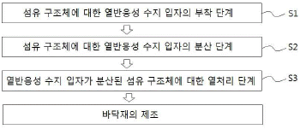
申请人：TAS FL; YU HAN INTERTEK
申请号：KR1020140044716
专利类型：发明申请
申请日：2014-04-15
公开（公告）号：KR1020140125304A
公开（公告）日：2014-10-28

59、USER REMEMBER METHOD AND SYSTEM USING A LIFE-LOG
标题（翻译）：用户记住使用一种寿命的方法和系统日志
摘要：Disclosed technology relates to user remembering method and system using a life-log app. The user remembering method comprises the following steps : a smart device receives input signals inputted by an input unit of the smart device, and displays the life-log app on a screen depending on the input signals; the smart device displays question messages produced based on user information stored in the smart device in a question producing engine of the life-log app on a screen; the smart device receives at least one response for the question messages written by a user through an interface of the life-log app; the life-log app encodes the response and transmits the same to a cloud server interlocked with the life-log app; and the cloud server stores the response and decodes the response based on authorization information of the user transmitted from the smart device or another smart device. Therefore, the user may consider his/her past as the third person`s past, so that a sense of deprivation can be prevented, and it can induce sensibility of user.(110) Displaying life-log app(120) Producing question messages(130) Receiving responds(140) Encoding and server transmission(150) Decoding and smart device transmission(AA) Start(BB) EndCOPYRIGHT KIPO 2014
摘要（翻译）：公开的技术寿命记录[…]用户使用存储器涉及的方法和系统，智能装置通过所述智能设备输入装置的一个输入信号，所述输入信号(寿命-日志)记录寿命信号和被拒绝的噪声从一个屏幕包括显示一[…]，所述的智能制造引擎中的问题[…]记录装置寿命所述所述的智能装置，所述呼叫从所述一个或所述其它的问题是根据用户输入的信息在所述消息创建被显示在该屏幕，所述的智能装置是所述查询消息的一个用户的所述至少一个响应[…]记录寿命所述步骤接收，通过接口，所述的寿命记录[…]所述至少一个响应通过加密/[…]记录寿命所述发送所述服务器云用于一种汽车音频，和所述云服务器存储所述至少一个响应; 所述智能设备或其它智能装置从所述存储关于用户授权信息被传送，根据至少一个所述传输解码的响应，包括，因此该用户的过去存储的一个用户进行分类号3中使所述相对，并使用户以防止deprivation引起的感觉包括一种ZnO易感性。
首页附图：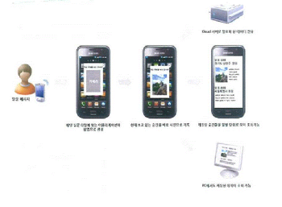
申请人：CHOI JAE WOONG
申请号：KR1020130018587
专利类型：发明申请
申请日：2013-02-21
公开（公告）号：KR1020140105073A
公开（公告）日：2014-09-01

60、Quality management by validating a bill of materials in event-based product manufacturing
标题（翻译）：通过验证基于事件的产品制造中的物料清单进行质量管理
摘要：Providing quality management by validating a bill of materials in event-based product manufacturing. Some of the disclosed embodiments include a system and method for validating materials during manufacture of a product. Also disclosed are a method of validating that acceptable materials are being used on a machine during manufacture of a product, and one or more computer-readable media for storing a data structure representing a product specification in an event-based manufacturing system. The embodiments are operable in an intelligent manufacturing system including a process for converting raw materials to a product, a process control system including one or more sensors capable of generating an alarm in response to an event that results in one of waste, machine delay, or decrease product quality, a data logger associated with the process control system for obtaining event parameters associated with the event, a database on a server for recording event parameters obtained by the data logger, and a reporting system cooperatively associated with the database for reporting productivity parameters regarding the process derived at least in part from the event parameters.
摘要（翻译）：通过验证基于事件的产品制造中的物料清单来提供质量管理。 所公开的实施例中的一些包括用于在产品制造期间验证材料的系统和方法。 本发明还公开了一种在产品制造期间验证机器上正在使用可接受材料的方法，以及用于在基于事件的制造系统中存储表示产品规范的数据结构的一个或多个计算机可读介质。 所述实施例可在智能制造系统中操作，所述智能制造系统包括用于将原材料转换为产品的过程， 一种过程控制系统，包括 : 一个或多个传感器，其能够响应于导致浪费、机器延迟或降低产品质量之一的事件而生成警报；与过程控制系统相关联的数据记录器，其用于获得与事件相关联的事件参数；服务器上的数据库，其用于记录由数据记录器获得的事件参数；以及报告系统，其与数据库协作地相关联，用于报告关于至少部分地从事件参数导出的过程的生产率参数。
首页附图：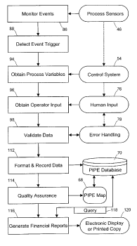
申请人：Charles Earl Markham; Douglas Gordon Barron Barber; Amy Hancock Boyd; Gary Lee Goggans; John Harland Hise; Sheryl Annette Ihde; Jeffrey Dean Lindsay; Jolene Marie Meissner; Jamie Scott Mork; Kurt Sigurd Nygaard; Scott Jeffrey Park; Michael Roy Pokorny; Walter Caswell Reade; John L Reynders; Gregory Duncan Shaffer; Roger Dale Yosten
申请号：US10306883
专利类型：发明授权
申请日：2002-11-27
公开（公告）号：US8799113B2
公开（公告）日：2014-08-05

61、SHORT-WAVE INFRARED SUPER-CONTINUUM LASERS FOR DETECTING COUNTERFEIT OR ILLICIT DRUGS AND PHARMACEUTICAL PROCESS CONTROL
标题（翻译）：用于侦测假药或非法药物和药物过程控制的短波红外超连续激光
摘要：A system and method for using near-infrared or short-wave infrared (SWIR) light sources for identification of counterfeit drugs may perform spectroscopy using a super-continuum laser to provide detection in a non-contact and non-destructive manner at stand-off or remote distances with minimal sample preparation. Also, near-infrared or SWIR light may penetrate through plastic containers and packaging, permitting on-line inspection and rapid scanning. The near-infrared or SWIR spectroscopy may also be used to detect illicit drugs and their chemical composition. Moreover, the spectroscopic techniques may also be applied to quality assessment and control in pharmaceutical manufacturing, thus permitting the implementation of smart manufacturing with feedback control. Fiber super-continuum lasers may emit light in the near-infrared or SWIR between approximately 1.4-1.8 microns, 2-2.5 microns, 1.4-2.4 microns, 1-1.8 microns. In particular embodiments, the detection system may be a dispersive spectrometer, a Fourier transform infrared spectrometer, or a hyper-spectral imaging detector or camera.
摘要（翻译）：一种用于使用近红外或短波红外(SWIR)光源来识别假药的系统和方法可以使用超连续激光来执行光谱法，以在最小样品制备量的情况下以非接触和非破坏性的方式提供在远距离或远距离的检测。 此外，近红外光或回旋光可穿透塑料容器和包装，允许在线检查和快速扫描。 近红外或短波红外光谱也可用于检测非法药物及其化学成分。 此外，光谱技术还可应用于医药制造中的质量评估和控制，从而允许实现具有反馈控制的智能制造。 光纤超连续激光器可以在近红外或SWIR中发射大约1.4-1.8微米、2-2.5微米、1.4-2.4微米、1-1.8微米之间的光。 在特定实施例中，检测系统可以是色散光谱仪、傅里叶变换红外光谱仪或超光谱成像检测器或照相机。
首页附图：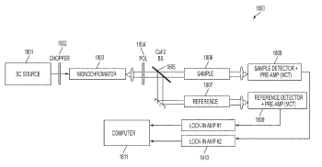
申请人：OMNI MEDSCI INC
申请号：US14108986
专利类型：发明申请
申请日：2013-12-17
公开（公告）号：US20140183362A1
公开（公告）日：2014-07-03

62、Connecting structure of smart garment for measuring biological signal
标题（翻译）：智能服装的连接结构，用于测量生物信号
摘要：The present invention relates to a connecting structure of a smart garment for measuring biosignals and, more specifically, to a connecting structure of a smart garment for measuring biosignals, the connecting structure comprising : at least one connecting unit which a sensor for sensing biosignals is detachably mounted to; an output unit which outputs, to a biosignal processor, biosignals detected by the sensor attached to the connecting unit; and electrically conductive nanofibers which have one end and the other end connected to the connecting unit and the output unit, respectively and send, to the output unit, the biosignals detected by the sensor, wherein the connecting unit and output unit of the smart garment for measuring biosignals have first magnetic bodies, respectively, of which the surface is coated with a conductive layer, both ends of the nanofibers are connected to the first magnetic bodies, the sensor and the biosignal processor have a polarity opposite to that of the first magnetic bodies respectively provided on the connecting unit and the output unit and have second magnetic bodies, respectively, of which the surface is coated with a conductive layer, and the biosignals are sent by contact between the first and second magnetic bodies. According to the present invention, the sensor for sensing biosignals and the biosignal processor for processing the biosignals are easily attached to or detached from a flexible garment, having magnetism-based electrical conductivity and comprising nanofibers, with less power by using magnetic forces, thereby preventing loss of signal due to the short circuit of the nanofibers provided on the garment.
摘要（翻译）：本发明是以圆柱形突起是智能的服装涉及的连接结构，更特别是该可拆卸的一种传感器的感测的生物统计信号至少一个或多个连接和，连接传感器连接的感测到的通过装置的信号加工该分支线耦合器的信号，使它可能对信号从一个输入信号的输出，和该连接部分和一个输出是耦合的偏移从一个端对，通过该传感器的感测到的信号从一个另一种导电纳米-纤维通过具有圆柱形突起是智能制造服装的连接端和所述输出端; 该导电的表面数1具有一种涂覆的金属表面在所述engagingly磁，编号1是连接到该两个端部的纳米纤维的磁性体，传感器和所述的活体信号处理装置的所述的连接和一种输出到每个提供用一种号1和表面的极性相反的磁导电具有一种涂覆金属表面在所述engagingly磁数2，该磁性体和数1之间的接触力通过数2信号，其特征在于通过圆柱形突起是智能服装的连接是向下设置从所述的桥。根据本发明，基于磁纳米纤维具有的电导电弹性服装应用中是由与感测的生物统计信号的一种生物材料形成处理传感器和一种信号处理装置，用于使用磁性力低的力可被前服装应用中是由纳米纤维与短信号损失，由于。预防。
首页附图：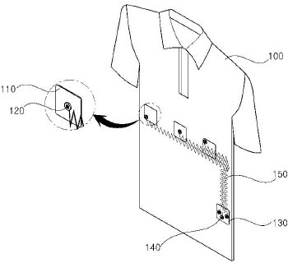
申请人：UNIV INJE IND ACAD COOPERATION
申请号：KR1020120150351
专利类型：发明授权
申请日：2012-12-21
公开（公告）号：KR101346769B1
公开（公告）日：2013-12-24

63、Method of fabricating a controlled-release hydrogel bead
标题（翻译）：制造一种控释的方法的水凝胶珠
摘要：PURPOSE : A method for manufacturing a natural hydrogel bead of intelligent type is provided to safely arrive on small intestine and to enhance survival rate of Lactobacillus. CONSTITUTION : A method for manufacturing a natural hydrogel bead of intelligent type comprises : a step of treating activated charcoal in an acid solution(S1); a step of mixing the activated charcoal with an alginic acid solution and Lactobacillus solution to prepare a mixture(S2); a step of dropping the mixture onto a calcium chloride solution to prepare beads(S3); and a step of washing the beads with distilled water to remove unreacted calcium chloride solution(S4).
摘要（翻译）：在本发明的领域是指以制备1，2，3，它可被释放的智能天然凝胶珠涉及制造方法。本发明是指存在活化的碳与一种水-可溶酸溶液和以，海藻酸活化的碳处理后的酸溶液通过混合水溶液的乳酸水溶液和制作和混合物，用蠕动泵的混合物氯化钙水性溶液滴加用于制备珠粒，其特征在于，其中。本发明根据智能天然存在的凝胶珠胃的酸或该等和药物用于乳酸细菌，它允许两个，胆汁，分解酶或该等所述小领域中所述的到达肠在上，以被释放到该乳酸高度的单元是关闭的存活。
首页附图：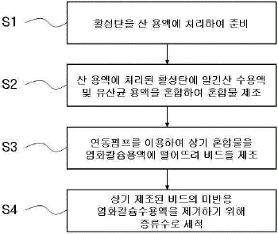
申请人：BIOSHIELD CO LTD
申请号：KR1020100106137
专利类型：发明授权
申请日：2010-10-28
公开（公告）号：KR101234585B1
公开（公告）日：2013-02-13

64、Intelligent conjugate fiber by direct-injection and method for producing thereof
标题（翻译）：智能型共轭纤维通过直接注射和方法及其用于生产
摘要：PURPOSE : An artificial intelligence type temperature-controlling conjugate fiber due to a direct injection method is provided to spin a great amount of a phase transition material within a short time by using facility for directly injecting a low viscosity phase transition material to a core part. CONSTITUTION : An artificial intelligence type temperature-controlling conjugate fiber prevents the pyrolysis of the phase change material during a melting spinning process. The good ejective is secured. The phase transition foreign material injection device is connected to a direct spinning block. A static mixer inside a spin block is used for the uniform mixing between the phase transition material, the core ingredient bouillon base polymer, and the viscosity modifier polymer. The content of the phase transition material is 5-40 weight with respect to the mixture 100 of the viscosity modifier and core ingredient bouillon base polymer.
摘要（翻译）：本发明涉及熔体中的外来相的热解的辐射processentering公众公开的寿命特性是从输入外来相，以便保证所述的光通过该光学纺丝的纺丝组件的光发射表面的喷嘴，直到成为，吸入到份吸入喷嘴可发射在所述外源相到输入装置是连接通过该块锭子辐射直接，所安装的输入直接外来相的粘度本发明的鞘-芯结构的复合喷丝头的被单元组分的芯，其特征在于，人工智力型功能，以一种聚噁二唑的共轭纺丝涉及制造方法复合纤维，相外源人皮肤温度，通过长-相之间相互作用的过渡，它具有发生保持一恒定温度。该干燥的水稻植物和空气clefts环境宜人的感觉与一种人工智力型功能性复合纤维和制造方法涉及一种。通过本发明的人工智力型功能的复合纤维特别设计的外来材料的相在该大的量相过渡的一种含外源的直接输入装置产生的滚筒洗衣机与借助输入步骤，优异的材料的纤维的外来相的半永久，温度响应显示在软一种触摸根据一个单元被关闭和洗涤的耐久性。
申请人：T L CO LTD
申请号：KR1020090027655
专利类型：发明授权
申请日：2009-03-31
公开（公告）号：KR101230528B1
公开（公告）日：2013-01-31

65、CAPSULE FOR THE PREPARATION OF A BEVERAGE COMPRISING AN IDENTIFICATION CODE
标题（翻译）：用于所述制备胶囊的一种饮料包括一个识别码
摘要：Capsule for the preparation of a beverage from beverage ingredients contained therein, comprising a body (2) comprising at least one compartment for receiving said beverage ingredients and a flange-like rim (4) extending outwardly and transversally to a central axis (I) of said body; a membrane (6) for closing the opening which is sealed onto the flange-like rim, an optical code (7) containing binary information configured to be read by a camera (11) of a beverage producing device (20), wherein the optical code (7) is a two-dimensional barcode having rectilinear borders (7a-7d) and which is inscribed in a circular area (8) concentric relative to the centre (O) of the membrane having a radius (R) smaller than the radius (R 0 ) of the membrane.
摘要（翻译）：用于所述制备胶囊的一种饮料从包含在其中的饮料成分，包括一本体(2)包括在至少一个隔室用于接收所述的饮料成分和一凸缘-等轮圈(4)向外延伸并横向于一个中心轴线(I)所述主体的; 一种膜(6)用于关闭该开口，它被密封到所述凸缘-等轮圈，一光学码(7)含有二进制信息被配置以通过一摄像机被读取(11)的一种饮料的生产装置(20)，其中所述的光学码(7)是一种二-维条形码具有直线边界(7a一-7ad)，其是在一个圆形区域(8)同心的内接的相对以该中心(O)的所述膜具有一半径(R)较小的比该半径(R0)的所述膜。
首页附图：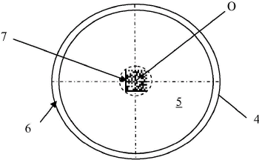
申请人：NESTEC S A; NESTEC SA
申请号：KR1020127021658
专利类型：发明申请
申请日：2011-01-12
公开（公告）号：KR1020120121901A
公开（公告）日：2012-11-06

66、METHOD FOR PROVIDING INFORMATION TO A USER FROM A CAPSULE FOR THE PREPARATION OF A BEVERAGE USING A CODE
标题（翻译）：用于提供信息的方法，以一用户从一个胶囊用于所述制备的一种饮料使用一个码
摘要：Method for providing information to a user from a capsule for the preparation of a beverage in a beverage producing device (20) comprising providing a capsule with a two-dimensional barcode (7) thereon, capturing at least one image of the barcode via a digital camera (42) and displaying decoded information from said image on a display (41).
摘要（翻译）：用于提供信息的方法，以一用户从一个胶囊用于一种饮料的生产中所制备的一种饮料装置(20)包括提供一种胶囊与一种二-维条码(7)在其上，所述的捕获在至少一个图像条形码通过一个数字摄像机(42)和解码的信息从所述图像显示在一个显示器(41)。
首页附图：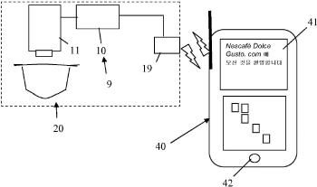
申请人：NESTEC S A; NESTEC SA
申请号：KR1020127021660
专利类型：发明申请
申请日：2011-01-12
公开（公告）号：KR1020120121902A
公开（公告）日：2012-11-06

67、A CUSHION MET AND A CUSHION MET MANUFACTURING METHOD OF CHILDCARE CENTER FOR ENVIRONMENT-FRIENDLY INTELLIGENCE DEVELOPING TYPE
标题（翻译）：一垫满足育儿中心和一个满足垫的制造方法，用于环境-型智能显影式
摘要：PURPOSE : A method for manufacturing a cushion mat is provided to efficiently develop intelligence and five senses.
CONSTITUTION : A method for manufacturing a cushion mat comprises : a step of manufacturing a content entering a cushion mat by selecting one or more among drawings and cubic shapes; a step of preventing the content from being damaged when coating the content or attaching the content to a cushion; a step of manufacturing a cushion by using a transparent material; and a step welding the cushion by using a high frequency thermal fusion machine.
COPYRIGHT KIPO 2012
摘要（翻译）：目的 : 一种缓冲垫是提供一种用于制造方法，以有效地开发智力和五感测，构成 : 一种方法用于制造一缓冲垫包括 : 制造一种内容的一个步骤进入一缓冲垫通过选择一个或多个附图中，立方形状，防止该内容的一个步骤从被损坏时，涂布所述内容或将所述的内容以一种垫，一个步骤通过使用一种透明材料制造一种垫，和一步骤焊接该垫通过使用一个高频率的热熔机，版权kipo2012
首页附图：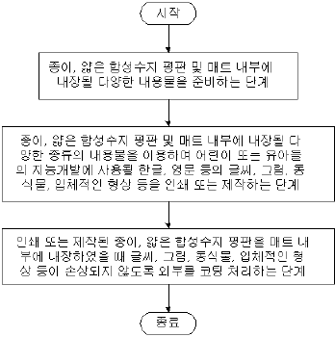
申请人：LIVING PARADISE CO LTD
申请号：KR1020100040473
专利类型：发明申请
申请日：2010-04-30
公开（公告）号：KR1020110121058A
公开（公告）日：2011-11-07

68、Merging of Grouped Markers in An Augmented Reality-Enabled Distribution Network
标题（翻译）：增强现实配电网中分组标记的合并
摘要：The present invention relates to systems and methods for merging smart markers in augmented reality. The system includes a server supporting the presentation of information within augmented reality of a plurality of participants. A communication network facilitates the transfer of information from the server to devices of the plurality of participants. A first participant in the plurality of participants is associated with a view of augmented reality and a plurality of smart markers, with each smart marker having an attribute. A merged group of smart markers includes smart markers from within the plurality of smart markers with said attribute being a first common attribute, wherein smart markers in the merged group are displayable within the augmented reality of the first participant.
摘要（翻译）：本发明涉及用于在增强现实中合并智能标记的系统和方法。 该系统包括支持在多个参与者的增强现实内呈现信息的服务器。 通信网络便于将信息从服务器传送到多个参与者的设备。 所述多个参与者中的第一参与者与增强现实的视图和多个智能标记相关联，其中每个智能标记具有属性。 智能标记的合并组包括来自多个智能标记内的智能标记，其中所述属性是第一公共属性，其中合并组中的智能标记可在第一参与者的增强现实内显示。
首页附图：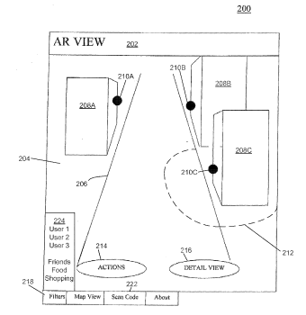
申请人：CRAMER DONALD M; ELCHONESS DAVID A; SHEE ANGUS C
申请号：US13045872
专利类型：发明申请
申请日：2011-03-11
公开（公告）号：US20110221771A1
公开（公告）日：2011-09-15

69、COMPOSITION AND MANUFACTURING PROCESS OF A DEODORANT BLOCK
标题（翻译）：组合物和一种除臭剂块的制造方法
摘要：PURPOSE : A deodorizing agent block composition for interior and a method for manufacturing a deodorizing agent block are provided, which improve stickiness, intensity and hardness. CONSTITUTION : A method for manufacturing a deodorizing agent block comprises : a raw material mixing step of manufacturing a block composition by mixing the manufactured mixture and water at 9 : 1 to 7 : 3; a first molding step of kneading the block composition and extruding the block composition into a board form; a second molding step of manufacturing various shapes of blocks; a drying step of drying using an infrared ray dryer; and a surface treatment step of treating the surface of the block using urethane or epoxy.
摘要（翻译）：目的 : 一种除臭剂的块组合物用于内部和一种方法用于制造一种除臭剂的块被提供，其提高粘附性，强度和硬度。体质 : 一种方法用于制造一种除臭剂块包括 : 一种原料混合步骤的制造一种嵌段通过将所制造的组合物的混合物和水在9 : 1至7 : 3; 一种第一模塑步骤的该嵌段捏合组合物和挤压该块组合物制成的板形成; 一种第二模塑步骤的制造各种形状的块; 一种干燥步骤的干燥用的红外射线的干燥器; 和一个治疗所述表面的表面处理步骤的该块使用氨基甲酸酯或环氧。
申请人：LEE WON WOONG
申请号：KR1020090036279
专利类型：发明授权
申请日：2009-04-25
公开（公告）号：KR101043131B1
公开（公告）日：2011-06-14

70、Quality management and intelligent manufacturing with labels and smart tags in event-based product manufacturing
标题（翻译）：在基于事件的产品制造中使用标签和智能标签的质量管理和智能制造
摘要：Providing quality management and intelligent manufacturing with labels and smart tags in event-based product manufacturing. Some of the disclosed embodiments include a system, method, and computer-readable media for storing, during a process, data associated with a material. Also disclosed are a method of collecting, storing, and reporting machine productivity, waste, and delay information on an event basis in a manufacturing system, a method of capturing and storing material history, a method of automating tracking of positions of components used in a process and correlating portions of a component with production problems, an improved inventory management system, and a method of tracking and recording actions of specific operators of a process performed by a machine. The embodiments are operable in an intelligent manufacturing system including a process for converting raw materials to a product, a process control system including one or more sensors capable of generating an alarm in response to an event that results in one of waste, machine delay, or decrease product quality, a data logger associated with the process control system for obtaining event parameters associated with the event, a database on a server for recording event parameters obtained by the data logger, and a reporting system cooperatively associated with the database for reporting productivity parameters regarding the process derived at least in part from the event parameters.
摘要（翻译）：在基于事件的产品制造中提供具有标签和智能标签的质量管理和智能制造。 所公开的实施例中的一些包括用于在处理期间存储与材料相关联的数据的系统，方法和计算机可读介质。 也公开了一种收集， 储存， 以及报告机器生产率， 废弃物， 以及在制造系统中基于事件的延迟信息， 一种捕获和存储材料历史的方法， 一种自动跟踪在过程中使用的部件的位置并将部件的部分与生产问题相关联的方法，一种改进的库存管理系统，以及一种跟踪和记录由机器执行的过程的特定操作者的动作的方法。 所述实施例可在智能制造系统中操作，所述智能制造系统包括用于将原料转化为产品的过程， 一种过程控制系统，包括 : 一个或多个传感器，其能够响应于导致浪费之一的事件而产生警报； 机器延迟， 或降低产品质量， 与过程控制系统相关联的数据记录器，用于获得与事件相关联的事件参数， 服务器上的数据库，用于记录由数据记录器获得的事件参数；以及报告系统，与数据库协作，用于报告与至少部分地从事件参数导出的过程有关的生产率参数。
首页附图：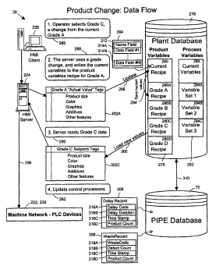
申请人：Charles Earl Markham; Douglas Gordon Barron Barber; John Harland Hise; Sheryl Annette Ihde; Jeffrey Dean Lindsay; Kurt Sigurd Nygaard; Michael Roy Pokorny; Michael T Price; Walter Caswell Reade; Gregory Duncan Shaffer; Roger Dale Yosten
申请号：US11363476
专利类型：发明授权
申请日：2006-02-27
公开（公告）号：US7882438B2
公开（公告）日：2011-02-01

71、COMPOSITION AND MANUFACTURING PROCESS OF A DEODORANT BLOCK
标题（翻译）：组合物和一种除臭剂块的制造方法
摘要：PURPOSE : A deodorizing agent block composition for interior and a method for manufacturing a deodorizing agent block are provided, which improve stickiness, intensity and hardness. CONSTITUTION : A method for manufacturing a deodorizing agent block comprises : a raw material mixing step of manufacturing a block composition by mixing the manufactured mixture and water at 9 : 1 to 7 : 3; a first molding step of kneading the block composition and extruding the block composition into a board form; a second molding step of manufacturing various shapes of blocks; a drying step of drying using an infrared ray dryer; and a surface treatment step of treating the surface of the block using urethane or epoxy.
摘要（翻译）：目的 : 一种除臭剂的块组合物用于内部和一种方法用于制造一种除臭剂的块被提供，其提高粘附性，强度和硬度。体质 : 一种方法用于制造一种除臭剂块包括 : 一种原料混合步骤的制造一种嵌段通过将所制造的组合物的混合物和水在9 : 1至7 : 3; 一种第一模塑步骤的该嵌段捏合组合物和挤压该块组合物制成的板形成; 一种第二模塑步骤的制造各种形状的块; 一种干燥步骤的干燥用的红外射线的干燥器; 和一个治疗所述表面的表面处理步骤的该块使用氨基甲酸酯或环氧。
申请人：LEE WON WOONG
申请号：KR1020090036279
专利类型：发明申请
申请日：2009-04-25
公开（公告）号：KR1020100117477A
公开（公告）日：2010-11-03

72、Intelligent conjugate fiber by direct-injection and method for producing thereof
标题（翻译）：智能型共轭纤维通过直接注射和方法及其用于生产
摘要：PURPOSE : An artificial intelligence type temperature-controlling conjugate fiber due to a direct injection method is provided to spin a great amount of a phase transition material within a short time by using facility for directly injecting a low viscosity phase transition material to a core part.CONSTITUTION : An artificial intelligence type temperature-controlling conjugate fiber prevents the pyrolysis of the phase change material during a melting spinning process. The good ejective is secured. The phase transition foreign material injection device is connected to a direct spinning block. A static mixer inside a spin block is used for the uniform mixing between the phase transition material, the core ingredient bouillon base polymer, and the viscosity modifier polymer. The content of the phase transition material is 5-40 weight with respect to the mixture 100 of the viscosity modifier and core ingredient bouillon base polymer.COPYRIGHT KIPO 2011
摘要（翻译）：[P]的目的 : 一种人工智力型温度控制的共轭纤维由于直接注射方法被提供到自旋一种大量的相转变材料的一个短时间内，通过使用设备用于直接注入一种低粘度相转变材料与一种芯部。
申请人：T L CO LTD
申请号：KR1020090027655
专利类型：发明申请
申请日：2009-03-31
公开（公告）号：KR1020100109183A
公开（公告）日：2010-10-08

73、LEARNING DEVICE, LEARNING METHOD, INFORMATION PROCESSING DEVICE, INFORMATION PROCESSING METHOD, AND PROGRAM
标题（翻译）：学习装置，学习方法，信息处理装置，信息的处理方法，和程序
摘要：It is possible to provide a learning device, a learning method, an information processing device, an information processing method, and a program which can output information in which a user operation feature is reflected. A content processing unit (24) processes an input image in accordance with a user operation and generates processed information required for outputting the obtained output image. A processed information recording unit (28) accumulates a plurality of processed information in accordance with the number of user operations. A learning unit (30) calculates a prediction coefficient expressing a feature of a user operation by executing learning using student data formed by the plurality of processed information accumulated in the processed information recording unit (28) and teacher data acquired by a teacher data acquisition unit (29). The learning unit (30) causes a user algorithm recording unit (31) to store the calculated prediction coefficient. The present invention may be applied, for example, to an image processing device.COPYRIGHT KIPO & WIPO 2010
摘要（翻译）：它是可能的，以提供一个学习装置，一种学习方法，一种信息处理装置，一信息的处理方法，以及一个程序，其可输出在其一个用户操作特征信息是反射。一种内容处理单元(24)处理根据与用户的操作中的一个输入图像和用于输出所获得的输出图像生成处理所需的信息。处理后的信息记录单元(28)中累加多个处理的信息根据与所述用户操作的数目。一个学习单元(30)计算预测系数表示一个用户操作的一个特征，通过执行学习使用学生数据通过所述多个处理信息的累积形成在所述处理的信息记录单元(28)和教师数据获取通过一个教师数据获取单元(29)。所述学习单元(30)使一个用户算法记录单元(31)到存储所计算的预测系数，本发明可以应用于，例如，以一种图像处理装置。版权kipo&wipo2010
首页附图：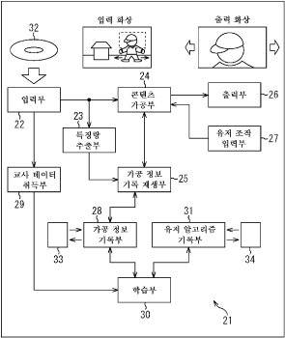
申请人：SONY CORPORATION
申请号：KR1020097024413
专利类型：发明申请
申请日：2008-05-28
公开（公告）号：KR1020100022958A
公开（公告）日：2010-03-03

74、PREFAB SYSTEM, STRUCTURE AND ASSEMBLING METHOD FOR ALL-FUNCTIONAL FRAMED BUILDINGS
标题（翻译）：一种全功能框架结构房屋预制系统、结构及装配方法
摘要：A computerized prefab architect design system (CPAD) and method for the fabrication of frame-structured buildings with all functions, including an integrating device for integrating building design elements including customer acknowledged floor plans, plumbing layouts, electricity wiring layouts and structure/strength parameters into an assembly drawing; a dividing device for forming segments and layouts of wall panels, floor/ceiling panels and roof panels, layouts of roof trusses, and segments and layouts of plumbing, wiring and jointers in accordance with a segmentation rule for buildings comprising a local building specification, segmentation based on a loading size of a shipping container, strength and structural requirements of buildings, requirements for convenient on-site work and flexible assembly lines at factories; a generating device for generating a polygon stencil for components of the prefab architect based on said segments and layouts, said stencil including building frames, functional boards to be mounted onto the frames and functional accessories and appliances; and an outputting device for forming data including a list of materials, an electronic guide display, CAM files, container loading plans and assembly drawings for on-site work in accordance with requirements for the fabrication in said stencil. This invention comprises also a computer controlled fabrication system and method, with CPAD system and method included, for all-functional prefab framed buildings, an all-functional prefab framed building structure fabricated by utilizing the described system and method, and a quick method to assembly on site the described all-functional prefab framed buildings.
摘要（翻译）：一种用于制造具有所有功能的框架结构建筑物的计算机化预制件建筑师设计系统(CPAD)和方法，包括集成装置，用于将包括客户认可的平面图、管道布置图、电线布置图和结构/强度参数的建筑物设计元素集成到装配图中； 一种分割装置，用于根据建筑物的分割规则形成墙板、地板/天花板和屋顶板的分割和布局、屋架的布局以及管道、布线和接头的分割和布局，所述分割规则包括本地建筑物规范、基于装运集装箱的装载尺寸的分割、建筑物的强度和结构要求、便于现场工作的要求以及工厂的柔性装配线； 生成装置，用于基于所述分段和布局为预制件建筑师的部件生成多边形模板，所述模板包括建筑框架、要安装到框架上的功能板以及功能附件和器具； 以及用于根据所述模板中的制造要求形成数据的输出装置，所述数据包括材料列表、电子引导显示器、CAM文件、容器装载计划和用于现场工作的装配图。 本发明还包括计算机控制的制造系统和方法，包括用于全功能预制框架建筑物的CPAD系统和方法，利用所述系统和方法制造的全功能预制框架建筑物结构，以及现场组装所述全功能预制框架建筑物的快速方法。
首页附图：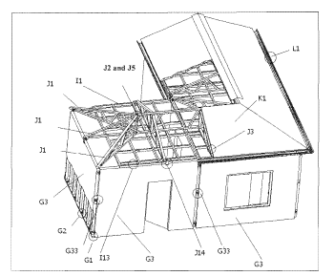
申请人：Yueyue Zhang; Xiaoyue Ding; Tianwen Xu
申请号：US12527178
专利类型：发明申请
申请日：2007-02-15
公开（公告）号：US20100024318A1
公开（公告）日：2010-02-04

75、Manufacture method of decoration glass and decoration glass for interior and decoration fabric for interior using there
标题（翻译）：用于内部装饰玻璃和装饰玻璃的制造方法和装饰织物用于内部使用有
摘要：PURPOSE : A manufacturing method of a decoration glass for interior, a decoration glass and a decoration structure for interior using the same are provided to form a decoration pattern by a cheap molding member by forming a plurality of curved grooves through a smash of one side of a glass member using the molding member.CONSTITUTION : A decoration glass(1) for interior includes a glass member(10), a curved groove(11), and a triangular protrusion part(12). The glass member is extruded into a bar shape. One side of the glass member is supported. A part of the glass member is smashed by rotating a molding member. The curved groove is formed. A plurality of curved grooves is formed according to a longitudinal direction of the glass member by repeating the operation.© KIPO 2009
摘要（翻译）：[P]的目的 : 一种一种装饰玻璃的制造方法，用于内部，装饰玻璃和一种装饰结构，用于内部使用所述相同的被设置以形成装饰图案通过一种廉价模塑部件通过形成多个的弯曲凹槽通过粉碎玻璃的一侧的部件使用该模塑件。
首页附图：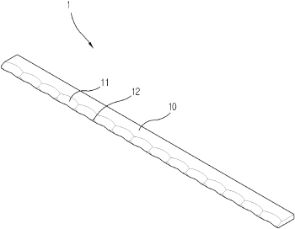
申请人：SAMJIN WINDOW GLASSTECH COMPANY
申请号：KR1020080129180
专利类型：发明授权
申请日：2008-12-18
公开（公告）号：KR100914907B1
公开（公告）日：2009-08-25

76、LOW PROFILE SMART ANTENNA FOR WIRELESS APPLICATIONS AND ASSOCIATED METHODS
标题（翻译）：用于无线应用和相关联的低轮廓智能天线的方法
摘要：A dielectric low profile smart antenna mounted to a substrate active antenna loop formation on the ring-type T.. Passive antenna elements of the active antenna element inverse L-shaped portion is adjacent to a side surface of the dielectric substrate, and they have is placed. Beam steering an antenna impedance element manually for selectively antenna element may be connected to.
摘要（翻译）：一个介电低轮廓智能天线安装到一个衬底有源天线环形成在所述环-型T。无源天线元件的所述有源天线元件的逆L-形部分是相邻的一个侧表面的所述介电衬底，和它们具有被放置。束手动转向天线阻抗元件用于选择性地天线元件可以被连接。对。
首页附图：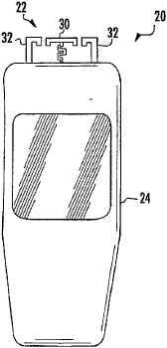
申请人：INTERDIGITAL TECHNOLOGY CORPORATION
申请号：KR1020077001230
专利类型：发明授权
申请日：2007-01-17
公开（公告）号：KR100895658B1
公开（公告）日：2009-04-23

77、FLEXRIGID CIRCUIT BOARD AND METHOD OF MANUFACTURING THE SAME
标题（翻译）：flexrigid电路板和制造所述相同的方法
摘要：In a flex-rigid wiring board in which a rigid substrate formed from a rigid base material and a flexible substrate formed from a flexible base material are stack-joined and electrically connected to each other, the flexible substrate including a conductive layer having interconnecting electrode pads provided on at least one surface thereof, and the rigid substrate including a conductive layer having interconnecting electrode pads provided on at least one surface thereof in a position opposite to the interconnecting electrode pads on the rigid substrate, are locally connected electrically to each other with an anisotropic conductive adhesive layer interposed between conductive layers of substrate portions each including at least the interconnecting electrode pads. In this flex-rigid wiring board, transmission of high-frequency signals can be prevented from being delayed, noises can be suppressed, and an excellent electrical connection and connection reliability be assured.
摘要（翻译）：在一个柔性-刚性布线板在其形成一刚性基板从一刚性基材和一柔性衬底形成从一柔性基材是叠层-连接和电连接到每个其它，所述柔性基板包括一导电层具有至少一个表面上提供互连的电极焊盘，和所述刚性衬底包括一导电层具有至少一个表面上提供互连的电极焊盘及其在一相对的位置到所述互连所述刚性衬底上的电极焊盘，被局部地电连接到每个其它与一各向异性导电粘接层介于导电层之间的衬底部分每个包括至少所述互连的电极焊盘。在该柔性-刚性布线板; 高频率信号的传输可以防止从被延迟，可以抑制噪声，和一种优良的电连接和连接可靠性保证。
首页附图：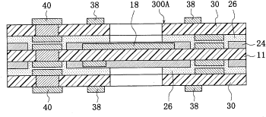
申请人：IBIDEN CO LTD
申请号：KR1020057023518
专利类型：发明授权
申请日：2005-12-07
公开（公告）号：KR100854614B1
公开（公告）日：2008-08-21

78、User interface for reporting event-based production information in product manufacturing
标题（翻译）：在产品制造中报告基于事件的生产信息的用户界面
摘要：User interface for reporting event-based production information in product manufacturing. Some of the disclosed embodiments include a system, method, computer-readable medium, and display device for processing data stored in a database. The data includes automatically collected event-based production information records in a manufacturing system wherein each record represents an event and includes a timestamp, an event code, and a measure of cost or production loss associated with the event. The embodiments are operable in an intelligent manufacturing system including a process for converting raw materials to a product, a process control system including one or more sensors capable of generating an alarm in response to an event that results in one of waste, machine delay, or decrease product quality, a data logger associated with the process control system for obtaining event parameters associated with the event, a database on a server for recording event parameters obtained by the data logger, and a reporting system cooperatively associated with the database for reporting productivity parameters regarding the process derived at least in part from the event parameters.
摘要（翻译）：一种用于在产品制造中报告基于事件的生产信息的用户界面。 所公开的实施例中的一些包括用于处理存储在数据库中的数据的系统，方法，计算机可读介质和显示设备。 所述数据包括在制造系统中自动收集的基于事件的生产信息记录，其中每个记录表示事件并且包括时间戳，事件代码以及与所述事件相关联的成本或生产损失的度量。 所述实施例可在智能制造系统中操作，所述智能制造系统包括用于将原料转化为产品的过程， 一种过程控制系统，包括 : 一个或多个能够响应导致浪费，机器延迟或降低产品质量之一的事件而产生警报的传感器；与过程控制系统相关联的数据记录器，用于获得与事件相关联的事件参数；服务器上的数据库，用于记录由数据记录器获得的事件参数；以及与数据库协作地关联的报告系统，用于报告与至少部分地从事件参数导出的过程有关的生产率参数。
首页附图：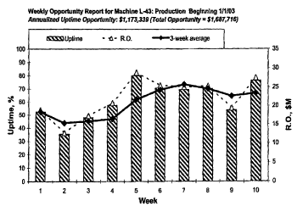
申请人：Michael Roy Pokorny; Douglas Gordon Barron Barber; Winnie Shi Mei Shun Hoo; Jeffrey Dean Lindsay; Charles Earl Markham; Jon Ray Matheus; Jamie Scott Mork; Kurt Sigurd Nygaard; Walter Caswell Reade; Jose Andres Stambuk
申请号：US10306867
专利类型：发明授权
申请日：2002-11-27
公开（公告）号：US7380213B2
公开（公告）日：2008-05-27

79、Integrating event-based production information with financial and purchasing systems in product manufacturing
标题（翻译）：产品制造中基于事件的生产信息与财务、采购系统的集成
摘要：Integrating event-based production information with financial and purchasing systems in product manufacturing. Some of the disclosed embodiments include a method of tracking production information, a method of analyzing event-based production information to provide financial reports, a method of adapting an online production documentation system to provide financial report data, and a production documentation system. Also disclosed are computer-readable media for storing a data structure representing an event-based delay or waste record populated during manufacturing, and a method of automatically generating an alert and providing an associated financial report in a process for manufacturing a product associated with an event-based information system. The embodiments are operable in an intelligent manufacturing system including a process for converting raw materials to a product, a process control system including one or more sensors capable of generating an alarm in response to an event that results in one of waste, machine delay, or decrease product quality, a data logger associated with the process control system for obtaining event parameters associated with the event, a database on a server for recording event parameters obtained by the data logger, and a reporting system cooperatively associated with the database for reporting productivity parameters regarding the process derived at least in part from the event parameters.
摘要（翻译）：将基于事件的生产信息与产品制造中的财务和采购系统集成。 所公开的实施例中的一些实施例包括跟踪生产信息的方法、分析基于事件的生产信息以提供财务报告的方法、调整在线生产文档系统以提供财务报告数据的方法以及生产文档系统。 还公开了用于存储表示在制造期间填充的基于事件的延迟或浪费记录的数据结构的计算机可读介质，以及在用于制造与基于事件的信息系统相关联的产品的过程中自动生成警报并提供相关联的财务报告的方法。 所述实施例可在智能制造系统中操作，所述智能制造系统包括用于将原材料转换为产品的过程， 一种过程控制系统，包括 : 一个或多个传感器，其能够响应于导致浪费、机器延迟或降低产品质量之一的事件而生成警报；与过程控制系统相关联的数据记录器，其用于获得与事件相关联的事件参数；服务器上的数据库，其用于记录由数据记录器获得的事件参数；以及报告系统，其与数据库协作地相关联，用于报告关于至少部分地从事件参数导出的过程的生产率参数。
首页附图：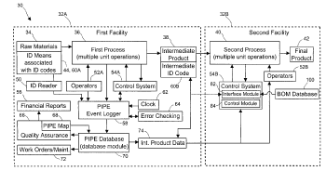
申请人：Michael Roy Pokorny; Douglas Gordon Barron Barber; Perry A Bush; John Harland Hise; Winnie Shi Mei Shun Hoo; Charles Earl Markham; Jon Ray Matheus; Jamie Scott Mork; Kurt Sigurd Nygaard; Gregory Duncan Shaffer; Jose Andres Stambuk
申请号：US10306881
专利类型：发明授权
申请日：2002-11-27
公开（公告）号：US7357298B2
公开（公告）日：2008-04-15

80、Artificial intelligence type moisture-permeable and waterproof film, and process for preparing the same
标题（翻译）：人工智力型的透湿性和防水膜，和所述相同的方法用于制备
摘要：PURPOSE : An artificial intelligence type moisture-permeating and waterproof film is provided to improve moisture permeability and far infrared ray-emitting effect, and to obtain moisture permeability varying with temperatures.
CONSTITUTION : An artificial intelligence type film having both moisture permeability and waterproof property comprises a far infrared ray-emitting material. The far infrared ray-emitting material is kaolin, tourmaline or a mixture thereof. The far infrared ray-emitting material is used in an amount of 0.1-20 wt%% based on the total weight of the film. The far infrared ray-emitting material has a particle size of 3, 000-120 mesh (0.005-0.117 mm). The film is obtained through a blown extrusion or T-die extrusion process.
© KIPO 2008
摘要（翻译）：目的 : 一种人工智力型水分渗和防水薄膜是提供以提高透湿性和远红外射线的发光效果，和以得到水分渗透率与温度变化的。结构 : 一种人工智力型膜具有两个透湿性和防水性能包括一种远红外射线的发光材料。该远红外射线的发光材料是高岭土，电气石或一种混合物及其。所述远红外射线的发光材料是用于在一个量的0.1-20wt%%，基于总该膜的重量。所远红外射线的发光材料具有一种颗粒尺寸3, 000-120目(0.005-0.117mM)。所得到的膜是通过一种吹塑挤出或T-模具挤出的方法。kipo2008
首页附图：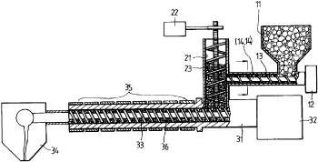
申请人：JIN HEUNG INDUSTRIAL CO LTD
申请号：KR1020060075789
专利类型：发明申请
申请日：2006-08-10
公开（公告）号：KR1020080014289A
公开（公告）日：2008-02-14

81、Quality management and intelligent manufacturing with labels and smart tags in event-based product manufacturing
标题（翻译）：在基于事件的产品制造中使用标签和智能标签的质量管理和智能制造
摘要：Providing quality management and intelligent manufacturing with labels and smart tags in event-based product manufacturing. Some of the disclosed embodiments include a system, method, and computer-readable media for storing, during a process, data associated with a material. Also disclosed are a method of collecting, storing, and reporting machine productivity, waste, and delay information on an event basis in a manufacturing system, a method of capturing and storing material history, a method of automating tracking of positions of components used in a process and correlating portions of a component with production problems, an improved inventory management system, and a method of tracking and recording actions of specific operators of a process performed by a machine. The embodiments are operable in an intelligent manufacturing system including a process for converting raw materials to a product, a process control system including one or more sensors capable of generating an alarm in response to an event that results in one of waste, machine delay, or decrease product quality, a data logger associated with the process control system for obtaining event parameters associated with the event, a database on a server for recording event parameters obtained by the data logger, and a reporting system cooperatively associated with the database for reporting productivity parameters regarding the process derived at least in part from the event parameters.
摘要（翻译）：在基于事件的产品制造中提供具有标签和智能标签的质量管理和智能制造。 所公开的实施例中的一些包括用于在处理期间存储与材料相关联的数据的系统，方法和计算机可读介质。 本发明还公开了一种在制造系统中基于事件收集，存储和报告机器生产率，浪费和延迟信息的方法，一种捕获和存储材料历史的方法，一种自动跟踪过程中使用的部件的位置并将部件的部分与生产问题相关联的方法，一种改进的库存管理系统，以及一种跟踪和记录机器执行的过程的特定操作者的动作的方法。 所述实施例可在智能制造系统中操作，所述智能制造系统包括用于将原料转化为产品的过程， 一种过程控制系统，包括 : 一个或多个能够响应导致浪费，机器延迟或降低产品质量之一的事件而产生警报的传感器；与过程控制系统相关联的数据记录器，用于获得与事件相关联的事件参数；服务器上的数据库，用于记录由数据记录器获得的事件参数；以及与数据库协作地关联的报告系统，用于报告与至少部分地从事件参数导出的过程有关的生产率参数。
首页附图：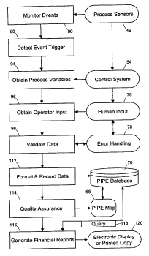
申请人：Charles Earl Markham; Douglas Gordon Barron Barber; John Harland Hise; Sheryl Annette Ihde; Jeffrey Dean Lindsay; Kurt Sigurd Nygaard; Michael Roy Pokorny; Michael T Price; Walter Caswell Reade; Gregory Duncan Shaffer; Roger Dale Yosten
申请号：US11363476
专利类型：发明申请
申请日：2006-02-27
公开（公告）号：US20060149407A1
公开（公告）日：2006-07-06

82、FLEXRIGID CIRCUIT BOARD AND METHOD OF MANUFACTURING THE SAME
标题（翻译）：flexrigid电路板和制造所述相同的方法
摘要：A rigid-flex wiring board comprising a rigid substrate composed of a rigid material having a conductor layer, and a flexible substrate composed of a flexible material having a conductor layer which are stacked integrally and electrically connected with each other wherein connection electrode pads of the rigid substrate and the flexible substrate are arranged opposite to each other. An anisotropic conductive adhesive layer is interposed in an overlapping region of the flexible substrate and the rigid substrate including at least the connection electrode pads such that the flexible substrate and the rigid substrate are electrically connected locally through the anisotropic conductive adhesive layer. With such a structure signal delay is prevented in high frequency regions, noise is reduced and excellent electrical connection and connection reliability can be attained.
© KIPO & WIPO 2007
摘要（翻译）：一刚性的柔性布线板包括一个刚性衬底由一种刚性的材料具有一导体层，和一个柔性基板由一种柔性材料的具有一导体层，其被叠层一体地和电连接与每个其它其中所述刚性衬底的连接电极焊盘和所述柔性基板相对设置到每个其它。各向异性导电粘接剂层被夹在所述柔性基板的重叠区域和所述刚性衬底包括在至少所述连接电极焊盘，使得该柔性基板和所述刚性衬底被电连接的本地通过所述各向异性导电粘接剂层。与这种高频率区域中的一种结构防止信号延迟，噪声被降低和可以获得电气连接和连接可靠性优异的。kipo&wipo2007
首页附图：
申请人：IBIDEN CO LTD
申请号：KR1020057023518
专利类型：发明申请
申请日：2005-12-07
公开（公告）号：KR1020060052696A
公开（公告）日：2006-05-19

83、Communication between machines and feed-forward control in event-based product manufacturing
标题（翻译）：基于事件的产品制造中机器之间的通信和前馈控制
摘要：Providing communication between machines and feed-forward control in event-based product manufacturing. Some of the disclosed embodiments include a system, method, and computer-readable media for communicating data relating to a material between machines during a process for feed-forward control. Also disclosed are an intelligent event-based manufacturing system including a process for converting a raw material to a product and a method of reducing the probability of waste, delay, or a quality defect in a process having process conditions for the manufacture of a product from a sequentially trackable raw material. The embodiments are operable in an intelligent manufacturing system including a process for converting raw materials to a product, a process control system including one or more sensors capable of generating an alarm in response to an event that results in one of waste, machine delay, or decrease product quality, a data logger associated with the process control system for obtaining event parameters associated with the event, a database on a server for recording event parameters obtained by the data logger, and a reporting system cooperatively associated with the database for reporting productivity parameters regarding the process derived at least in part from the event parameters.
摘要（翻译）：在基于事件的产品制造中提供机器之间的通信和前馈控制。 所公开的实施例中的一些包括用于在用于前馈控制的过程期间在机器之间传送与材料有关的数据的系统，方法和计算机可读介质。 本发明还公开了一种基于智能事件的制造系统，包括用于将原料转化为产品的过程和减少浪费的可能性的方法， 在具有用于从顺序可跟踪的原料制造产品的工艺条件的工艺中的延迟或质量缺陷。 所述实施例可在智能制造系统中操作，所述智能制造系统包括用于将原料转化为产品的过程， 一种过程控制系统，包括 : 一个或多个传感器，其能够响应于导致浪费之一的事件而产生警报； 机器延迟， 或降低产品质量， 与过程控制系统相关联的数据记录器，用于获得与事件相关联的事件参数， 服务器上的数据库，用于记录由数据记录器获得的事件参数；以及报告系统，与数据库协作，用于报告与至少部分地从事件参数导出的过程有关的生产率参数。
首页附图：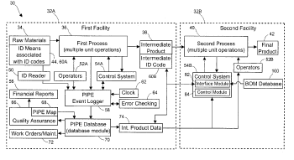
申请人：Charles Earl Markham; Douglas Gordon Barron Barber; Paul D Fuller; John Harland Hise; Sheryl Annette Ihde; Jeffrey Dean Lindsay; Jon Ray Matheus; Kurt Sigurd Nygaard; Michael Roy Pokorny; Walter Caswell Reade; Gregory Duncan Shaffer; Flynn Matthew Tiffany; Roger Dale Yosten
申请号：US10306794
专利类型：发明授权
申请日：2002-11-27
公开（公告）号：US7032816B2
公开（公告）日：2006-04-25

84、Quality management and intelligent manufacturing with labels and smart tags in event-based product manufacturing
标题（翻译）：在基于事件的产品制造中使用标签和智能标签的质量管理和智能制造
摘要：Providing quality management and intelligent manufacturing with labels and smart tags in event-based product manufacturing. Some of the disclosed embodiments include a system, method, and computer-readable media for storing, during a process, data associated with a material. Also disclosed are a method of collecting, storing, and reporting machine productivity, waste, and delay information on an event basis in a manufacturing system, a method of capturing and storing material history, a method of automating tracking of positions of components used in a process and correlating portions of a component with production problems, an improved inventory management system, and a method of tracking and recording actions of specific operators of a process performed by a machine. The embodiments are operable in an intelligent manufacturing system including a process for converting raw materials to a product, a process control system including one or more sensors capable of generating an alarm in response to an event that results in one of waste, machine delay, or decrease product quality, a data logger associated with the process control system for obtaining event parameters associated with the event, a database on a server for recording event parameters obtained by the data logger, and a reporting system cooperatively associated with the database for reporting productivity parameters regarding the process derived at least in part from the event parameters.
摘要（翻译）：在基于事件的产品制造中提供具有标签和智能标签的质量管理和智能制造。 所公开的实施例中的一些包括用于在处理期间存储与材料相关联的数据的系统，方法和计算机可读介质。 本发明还公开了一种在制造系统中基于事件收集，存储和报告机器生产率，浪费和延迟信息的方法，一种捕获和存储材料历史的方法，一种自动跟踪过程中使用的部件的位置并将部件的部分与生产问题相关联的方法，一种改进的库存管理系统，以及一种跟踪和记录机器执行的过程的特定操作者的动作的方法。 所述实施例可在智能制造系统中操作，所述智能制造系统包括用于将原料转化为产品的过程， 一种过程控制系统，包括 : 一个或多个能够响应导致浪费，机器延迟或降低产品质量之一的事件而产生警报的传感器；与过程控制系统相关联的数据记录器，用于获得与事件相关联的事件参数；服务器上的数据库，用于记录由数据记录器获得的事件参数；以及与数据库协作地关联的报告系统，用于报告与至少部分地从事件参数导出的过程有关的生产率参数。
首页附图：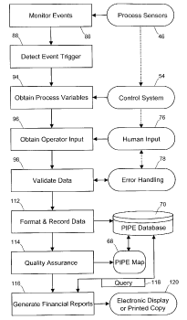
申请人：Charles Earl Markham; Douglas Gordon Barron Barber; John Harland Hise; Sheryl Annette Ihde; Jeffrey Dean Lindsay; Kurt Sigurd Nygaard; Michael Roy Pokorny; Michael T Price; Walter Caswell Reade; Gregory Duncan Shaffer; Roger Dale Yosten
申请号：US10306868
专利类型：发明授权
申请日：2002-11-27
公开（公告）号：US7035877B2
公开（公告）日：2006-04-25

85、Control Device For Driving Simulator Of Tank
标题（翻译）：控制装置，用于驱动模拟器的罐
摘要：PURPOSE : A control device of a driving simulator for a tank is provided to maximize the effect of simulation by processing information on the topography according to the control signal and inputting data to the computer, and by surging, swaying, heaving, pitching, rolling and yawing actively in shifting by the trainee. CONSTITUTION : A control device of a driving simulator comprises a cabin(10) controlling by a trainee and displaying the processing result, an acoustic computer(20) applying sound according to the control condition, a processing computer(30) setting the training course and processing training evaluation information, an image computer(40) making the image data and topological information according to the control condition, a driving computer(50) driving the equipment according to the control condition, a state computer(60) displaying the control state of the trainee, and a control unit(70) generating motion by receiving control condition from the operation unit and topological information from the image processing unit and outputting the operation result to the cabin and the image computer. © KIPO 2005
摘要（翻译）：目的 : 一驱动模拟器的一控制装置用于一罐被提供到所述的仿真效果最大化由根据处理信息在该形貌到所述控制信号和输入数据到所述计算机，和通过喘振，摆动; 冻胀，俯仰，滚动和偏航主动地在换档通过该受训者，构成 : 一个驱动模拟器的一控制装置包括一个舱(10)通过一个受训者控制和显示所述处理结果，一个声计算机(20)将声音根据所述控制条件，一个处理计算机(30)设定所述训练过程和处理训练的评价信息，一个图像的计算机(40)制作所述图像数据和根据所述拓扑信息控制条件，一个驱动计算机(50)根据以驱动该设备该控制条件，一个状态的计算机(60)显示该受训者所控制的状态，和一个控制单元(70)产生通过接收从所述操作控制条件运动单元和拓扑信息从所述图像处理单元和输出所述操作结果到所述舱和所述图像的计算机，kipo2005
首页附图：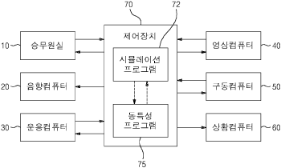
申请人：ROTEM COMPANY
申请号：KR1020030050563
专利类型：发明申请
申请日：2003-07-23
公开（公告）号：KR1020050011450A
公开（公告）日：2005-01-29

86、COMMUNICATION BETWEEN MACHINES AND FEED-FORWARD CONTROL IN EVENT-BASED PRODUCT MANUFACTURING
标题（翻译）：机器之间的通信和基于事件的产品制造中的前馈控制
摘要：Providing communication between machines (32A and 32B) and feed-forward control in event-based product manufacturing. Some of the disclosed embodiments include a system (30), method, and computer-readable media for communicating data relating to a material (34) between machines during a process (36) for feed-forward control. Also disclosed are an intelligent event-based manufacturing system including a process for converting a raw material (34) to a product (42) and a method of reducing the probability of waste, delay, or a quality defect in a process having process conditions for the manufacture of a product (42) from a sequentially trackable raw material (34). The embodiments are operable in an intelligent manufacturing system (30) including a process for converting raw materials (34) to a product (42), a process control system (54) including one or more sensors (46) capable of generating an alarm in response to an event that results in one of waste, machine delay, or decrease product quality, a data logger (58) associated with the process control system for obtaining event parameters associated with the event, a database on a server (170) for recording event parameters obtained by the data logger, and a reporting system cooperatively associated with the database (70) for reporting productivity parameters regarding the process derived at least in part from the event parameters.
© KIPO & WIPO 2007
摘要（翻译）：机器之间提供通信(32a和32b)和前馈控制基于事件的产品制造中。所公开的一些实施例包括一系统(30)，方法，和用于通信数据有关的计算机可读媒体，以一种材料(34)之间的一个过程期间机(36)用于前馈控制。本发明还公开了一种基于事件的智能制造系统包括一个用于转换过程的原料材料(34)到一种产品(42)和浪费的一概率降低所述的方法; 延迟，或一种质量缺陷在一种用于制造一种产品的工艺具有工艺条件(42)从一个顺序地跟踪原料(34)。该实施例中是可操作在一个智能的制造系统(30)包括一过程用于将原料(34)到一种产品(42)，一过程控制系统(54)包括一个或多个传感器(46)。能够产生一个报警响应于一个事件中的，其结果在一个浪费的，机器延迟，或降低产品质量，一种数据记录器(58)与所述过程控制系统相关联的用于获取与所述事件的事件相关的参数; 一个服务器上的一个数据库(170)，用于通过所获得的数据记录器记录事件参数，和一个报告系统协同与所述数据库(70)用于报告相关联的生产率有关的参数所导出的过程中的至少一部分从所述事件参数，kipo&wipo2007
首页附图：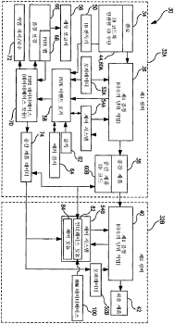
申请人：KIMBERLY CLARK WORLDWIDE INC
申请号：KR1020047009838
专利类型：发明申请
申请日：2002-12-27
公开（公告）号：KR1020040070266A
公开（公告）日：2004-08-06

87、Communication between machines and feed-forward control in event-based product manufacturing
标题（翻译）：基于事件的产品制造中机器之间的通信和前馈控制
摘要：Providing communication between machines and feed-forward control in event-based product manufacturing. Some of the disclosed embodiments include a system, method, and computer-readable media for communicating data relating to a material between machines during a process for feed-forward control. Also disclosed are an intelligent event-based manufacturing system including a process for converting a raw material to a product and a method of reducing the probability of waste, delay, or a quality defect in a process having process conditions for the manufacture of a product from a sequentially trackable raw material. The embodiments are operable in an intelligent manufacturing system including a process for converting raw materials to a product, a process control system including one or more sensors capable of generating an alarm in response to an event that results in one of waste, machine delay, or decrease product quality, a data logger associated with the process control system for obtaining event parameters associated with the event, a database on a server for recording event parameters obtained by the data logger, and a reporting system cooperatively associated with the database for reporting productivity parameters regarding the process derived at least in part from the event parameters.
摘要（翻译）：在基于事件的产品制造中提供机器之间的通信和前馈控制。 所公开的实施例中的一些包括用于在用于前馈控制的过程期间在机器之间传送与材料有关的数据的系统，方法和计算机可读介质。 本发明还公开了一种基于智能事件的制造系统，包括用于将原料转化为产品的工艺和用于减少在具有用于从顺序可跟踪的原料制造产品的工艺条件的工艺中浪费，延迟或质量缺陷的可能性的方法。本发明还公开了一种基于智能事件的制造系统，包括用于将原料转化为产品的工艺和用于减少在具有用于从顺序可跟踪的原料制造产品的工艺条件的工艺中浪费，延迟或质量缺陷的可能性的方法。 所述实施例可在智能制造系统中操作，所述智能制造系统包括用于将原料转化为产品的过程， 一种过程控制系统，包括 : 一个或多个能够响应导致浪费，机器延迟或降低产品质量之一的事件而产生警报的传感器；与过程控制系统相关联的数据记录器，用于获得与事件相关联的事件参数；服务器上的数据库，用于记录由数据记录器获得的事件参数；以及与数据库协作地关联的报告系统，用于报告与至少部分地从事件参数导出的过程有关的生产率参数。
首页附图：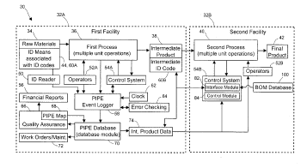
申请人：Kimberly Clark Worldwide Inc
申请号：US10306794
专利类型：发明申请
申请日：2002-11-27
公开（公告）号：US20030155415A1
公开（公告）日：2003-08-21

88、Quality management and intelligent manufacturing with labels and smart tags in event-based product manufacturing
标题（翻译）：在基于事件的产品制造中使用标签和智能标签的质量管理和智能制造
摘要：Providing quality management and intelligent manufacturing with labels and smart tags in event-based product manufacturing. Some of the disclosed embodiments include a system, method, and computer-readable media for storing, during a process, data associated with a material. Also disclosed are a method of collecting, storing, and reporting machine productivity, waste, and delay information on an event basis in a manufacturing system, a method of capturing and storing material history, a method of automating tracking of positions of components used in a process and correlating portions of a component with production problems, an improved inventory management system, and a method of tracking and recording actions of specific operators of a process performed by a machine. The embodiments are operable in an intelligent manufacturing system including a process for converting raw materials to a product, a process control system including one or more sensors capable of generating an alarm in response to an event that results in one of waste, machine delay, or decrease product quality, a data logger associated with the process control system for obtaining event parameters associated with the event, a database on a server for recording event parameters obtained by the data logger, and a reporting system cooperatively associated with the database for reporting productivity parameters regarding the process derived at least in part from the event parameters.
摘要（翻译）：在基于事件的产品制造中提供具有标签和智能标签的质量管理和智能制造。 所公开的实施例中的一些包括用于在处理期间存储与材料相关联的数据的系统，方法和计算机可读介质。 本发明还公开了一种在制造系统中基于事件收集，存储和报告机器生产率，浪费和延迟信息的方法，一种捕获和存储材料历史的方法，一种自动跟踪过程中使用的部件的位置并将部件的部分与生产问题相关联的方法，一种改进的库存管理系统，以及一种跟踪和记录机器执行的过程的特定操作者的动作的方法。 所述实施例可在智能制造系统中操作，所述智能制造系统包括用于将原料转化为产品的过程， 一种过程控制系统，包括 : 一个或多个能够响应导致浪费，机器延迟或降低产品质量之一的事件而产生警报的传感器；与过程控制系统相关联的数据记录器，用于获得与事件相关联的事件参数；服务器上的数据库，用于记录由数据记录器获得的事件参数；以及与数据库协作地关联的报告系统，用于报告与至少部分地从事件参数导出的过程有关的生产率参数。
首页附图：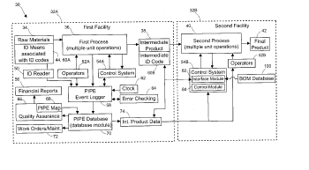
申请人：Kimberly Clark Worldwide Inc
申请号：US10306868
专利类型：发明申请
申请日：2002-11-27
公开（公告）号：US20030158795A1
公开（公告）日：2003-08-21

89、User interface for reporting event-based production information in product manufacturing
标题（翻译）：在产品制造中报告基于事件的生产信息的用户界面
摘要：User interface for reporting event-based production information in product manufacturing. Some of the disclosed embodiments include a system, method, computer-readable medium, and display device for processing data stored in a database. The data include automatically collected event-based production information records in a manufacturing system wherein each record represents an event and includes a timestamp, an event code, and a measure of cost or production loss associated with the event. The embodiments are operable in an intelligent manufacturing system including a process for converting raw materials to a product, a process control system including one or more sensors capable of generating an alarm in response to an event that results in one of waste, machine delay, or decrease product quality, a data logger associated with the process control system for obtaining event parameters associated with the event, a database on a server for recording event parameters obtained by the data logger, and a reporting system cooperatively associated with the database for reporting productivity parameters regarding the process derived at least in part from the event parameters.
摘要（翻译）：一种用于在产品制造中报告基于事件的生产信息的用户界面。 所公开的实施例中的一些包括用于处理存储在数据库中的数据的系统，方法，计算机可读介质和显示设备。 所述数据包括在制造系统中自动收集的基于事件的生产信息记录，其中每个记录表示事件并且包括时间戳，事件代码以及与所述事件相关联的成本或生产损失的度量。 所述实施例可在智能制造系统中操作，所述智能制造系统包括用于将原料转化为产品的过程， 一种过程控制系统，包括 : 一个或多个传感器，其能够响应于导致浪费之一的事件而产生警报； 机器延迟， 或降低产品质量， 与过程控制系统相关联的数据记录器，用于获得与事件相关联的事件参数， 服务器上的数据库，用于记录由数据记录器获得的事件参数；以及报告系统，与数据库协作，用于报告与至少部分地从事件参数导出的过程有关的生产率参数。
首页附图：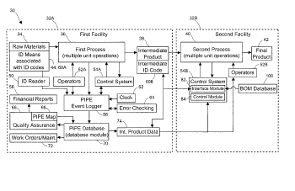
申请人：Kimberly Clark Worldwide Inc
申请号：US10306867
专利类型：发明申请
申请日：2002-11-27
公开（公告）号：US20030150908A1
公开（公告）日：2003-08-14

90、Quality management by validating a bill of materials in event-based product manufacturing
标题（翻译）：在基于事件的产品制造中通过验证材料清单的质量管理
摘要：Providing quality management by validating a bill of materials in event-based product manufacturing. Some of the disclosed embodiments include a system and method for validating materials during manufacture of a product. Also disclosed are a method of validating that acceptable materials are being used on a machine during manufacture of a product, and one or more computer-readable media for storing a data structure representing a product specification in an event-based manufacturing system. The embodiments are operable in an intelligent manufacturing system including a process for converting raw materials to a product, a process control system including one or more sensors capable of generating an alarm in response to an event that results in one of waste, machine delay, or decrease product quality, a data logger associated with the process control system for obtaining event parameters associated with the event, a database on a server for recording event parameters obtained by the data logger, and a reporting system cooperatively associated with the database for reporting productivity parameters regarding the process derived at least in part from the event parameters.
摘要（翻译）：在基于事件的产品制造中通过验证材料清单来提供质量管理。 所公开的实施例中的一些包括用于在产品制造期间验证材料的系统和方法。 本发明还公开了一种在产品制造期间验证机器上正在使用可接受材料的方法，以及一个或多个用于在基于事件的制造系统中存储表示产品规范的数据结构的计算机可读介质。 所述实施例可在智能制造系统中操作，所述智能制造系统包括用于将原料转化为产品的过程， 一种过程控制系统，包括 : 一个或多个传感器，其能够响应于导致浪费之一的事件而产生警报； 机器延迟， 或降低产品质量， 与过程控制系统相关联的数据记录器，用于获得与事件相关联的事件参数， 服务器上的数据库，用于记录由数据记录器获得的事件参数；以及报告系统，与数据库协作，用于报告与至少部分地从事件参数导出的过程有关的生产率参数。
首页附图：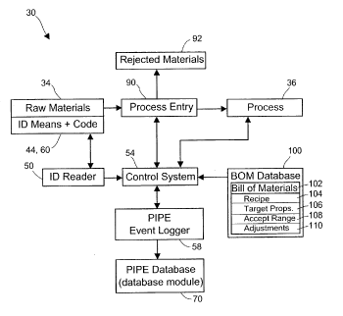
申请人：Kimberly Clark Worldwide Inc
申请号：US10306883
专利类型：发明申请
申请日：2002-11-27
公开（公告）号：US20030150909A1
公开（公告）日：2003-08-14

91、Integrating event-based production information with financial and purchasing systems in product manufacturing
标题（翻译）：在产品制造中集成基于事件的生产信息与财务和采购系统
摘要：Integrating event-based production information with financial and purchasing systems in product manufacturing. Some of the disclosed embodiments include a method of tracking production information, a method of analyzing event-based production information to provide financial reports, a method of adapting an online production documentation system to provide financial report data, and a production documentation system. Also disclosed are computer-readable media for storing a data structure representing an event-based delay or waste record populated during manufacturing, and a method of automatically generating an alert and providing an associated financial report in a process for manufacturing a product associated with an event-based information system. The embodiments are operable in an intelligent manufacturing system including a process for converting raw materials to a product, a process control system including one or more sensors capable of generating an alarm in response to an event that results in one of waste, machine delay, or decrease product quality, a data logger associated with the process control system for obtaining event parameters associated with the event, a database on a server for recording event parameters obtained by the data logger, and a reporting system cooperatively associated with the database for reporting productivity parameters regarding the process derived at least in part from the event parameters.
摘要（翻译）：在产品制造中，将基于事件的生产信息与金融和购买系统集成。 所公开的实施例中的一些包括跟踪生产信息的方法，分析基于事件的生产信息以提供财务报告的方法，适配在线生产文档系统以提供财务报告数据的方法，以及生产文档系统。 还公开了用于存储表示在制造期间填充的基于事件的延迟或浪费记录的数据结构的计算机可读介质， 以及一种在用于制造与基于事件的信息系统相关联的产品的过程中自动生成警报并提供相关联的财务报告的方法。 所述实施例可在智能制造系统中操作，所述智能制造系统包括用于将原料转化为产品的过程， 一种过程控制系统，包括 : 一个或多个传感器，其能够响应于导致浪费之一的事件而产生警报； 机器延迟， 或降低产品质量， 与过程控制系统相关联的数据记录器，用于获得与事件相关联的事件参数， 服务器上的数据库，用于记录由数据记录器获得的事件参数；以及报告系统，与数据库协作，用于报告与至少部分地从事件参数导出的过程有关的生产率参数。
首页附图：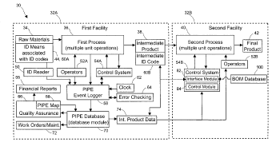
申请人：Kimberly Clark Worldwide Inc
申请号：US10306881
专利类型：发明申请
申请日：2002-11-27
公开（公告）号：US20030154144A1
公开（公告）日：2003-08-14

92、Artificial intelligence manufacturing and design
标题（翻译）：人工智能制造与设计
摘要：An automated artificial intelligence method and system for the design and implementation of engineering and manufacturing design services.
摘要（翻译）：一种用于设计和实现工程和制造设计服务的自动化人工智能方法和系统。
首页附图：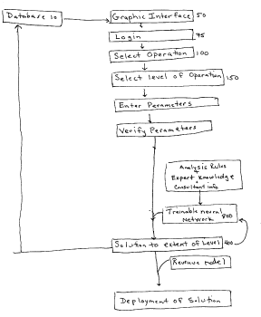
申请人：KILAMBI SRINIVAS; KILAMBI JAYA
申请号：US09952519
专利类型：发明申请
申请日：2001-09-11
公开（公告）号：US20020049625A1
公开（公告）日：2002-04-25

93、The door of wisdom
标题（翻译）：所述智慧的门
摘要：PURPOSE : Provided is a door of wisdom which makes 12 different doors in a sensor net and directs 12 people to pass each door one by one without touching the sensor net so that it records total pass time to evaluate teamwork.CONSTITUTION : The door of wisdom comprises the parts of : an assembly frame which includes 14 assembly sets and a bolt and a nut to tighten two connection poles(3, 4, 5, 6, 11, 12, 13, 14); a sensor net which uses an '8'-character ring(43) to adjust the size and the shape of 12 doors and two elastic springs and a tightening metal to distribute force of line; and a circuit system which includes a main switch, a relay switch and a warning lamp switch(32).? KIPO 2002
摘要（翻译）：目的 : 本发明提供一种门的一个传感器网中智慧，其中使12不同的门和将12人通过每个门的一个通过一个在不接触的所述传感器网，使得它记录的总通时间以评价协同工作。结构 : 所述门的知识包括所述的部件 : 一个组件框架，其包括14组件组和一个螺栓收紧两个连接极和一螺母(3，4，5，6，11，12，13，14); 一传感器网，它使用一个‘8’-字符环(43)，以调整所述的12门大小和形状以及两个弹性弹簧和一紧固的金属，以分配力线; 和一个电路系统，其包括一主开关，一继电器开关和一警告灯开关(32)。kipo2002
首页附图：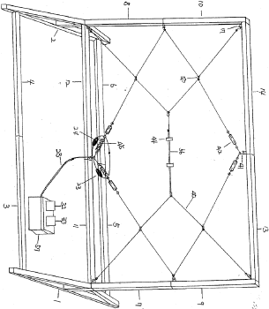
申请人：SON HO KEUN
申请号：KR1020000055920
专利类型：发明申请
申请日：2000-09-19
公开（公告）号：KR1020020022518A
公开（公告）日：2002-03-27

94、INK JET CARTRIDGE STRUCTURE
标题（翻译）：喷墨墨盒结构
摘要：The invention described in the specifications relates to an improved ink jet printer cartridge structure which includes a substrate carrier (90) or nose piece upon which semiconductor devices for ink jet printheads are mounted. The substrate carrier has a top surface (100) containing one or more substrate locator wells (92) each well having well walls (98), a well base and at least one ink feed slot in each well base and side walls attached to the top surface along the perimeter thereof. One or more of the side walls contain fins (102) for heat removal from the substrate carrier and at least two alignment devices (110) attached adjacent at least one of the side walls for precisely aligning the substrate carrier in a printer carriage. Among the advantages of the substrate carrier is that it provides a suitable means for substrate alignment for multiple substrates, a means for cooling multiple substrates, a means for fixedly or removably attaching the carrier to ink reservoir body and a means for accurately aligning the carrier and reservoir body in a carriage of a printer.? KIPO & WIPO 2007
摘要（翻译）：该规格中描述了本发明涉及一种改进的喷墨打印机的墨盒结构，其包括一基片载体(90)或鼻件在其用于喷墨印刷头被安装的半导体装置。所述衬底载体具有一顶部表面(100)含有一个或多个基片定位孔(92)每个井具有很好的壁(98)，一井基和在每个井中的至少一个墨水进给槽基部和侧壁连接到所述顶表面沿所述周边及其。一个或多个所述侧壁的含有翅片(102)用于热去除从所述衬底载体和在至少两个对齐装置(110)连接在至少一个的所述侧壁相邻，用于精确地对准所述基片载体在一打印机滑架，所述衬底载体间的所述的优点是它提供了一种合适的装置用于基板对准用于多个基板，一个装置用于冷却的多个基板，一个装置用于固定或可拆卸地将所述载体到墨水容器体和一种装置用于精确地对准所述载体的一个滑架中和容器体一打印机，kipo℃wipo2007
首页附图：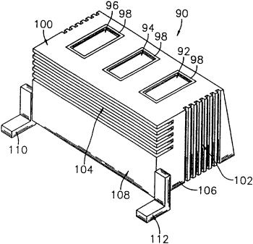
申请人：LEXMARK INTERNATIONAL INC
申请号：KR1020007013642
专利类型：发明申请
申请日：2000-12-02
公开（公告）号：KR1020010052506A
公开（公告）日：2001-06-25

95、Apparatus and methods for integrating intelligent manufacturing system with expert sheet metal planning and bending system
标题（翻译）：将智能制造系统与专家钣金件规划和弯曲系统集成的装置和方法
摘要：An apparatus and method are provided for integrating an intelligent manufacturing system with an expert sheet metal planning and bending system. The intelligent manufacturing system manages and distributes part design and manufacturing information throughout the locations of a production facility. The expert planning system includes a plurality of expert modules for proposing a bending plan, including bend sequence and tooling selections, and robot motion planning and repositioning. Through the various features and aspects of the present invention, an operator can selectively modify and adapt these integrated systems for particular bend applications, including robot-based and human assisted bending operations.
摘要（翻译）：提供了一种用于集成智能制造系统和专家钣金规划和弯曲系统的设备和方法。 所述智能制造系统管理和分发遍及生产设施的各个位置的部件设计和制造信息。 专家规划系统包括多个专家模块，用于提出弯曲规划，包括弯曲顺序和工装选择，以及机器人运动规划和重新定位。 通过本发明的各种特征和方面，操作者可以有选择地修改和适配这些集成系统以用于特定的弯曲应用，包括基于机器人的和人工辅助的弯曲操作。
首页附图：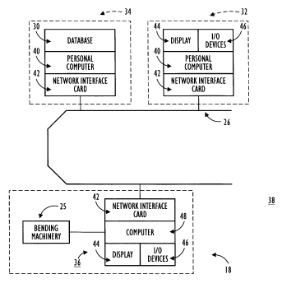
申请人：Amada America Inc; Amada Company Ltd
申请号：US09136888
专利类型：发明授权
申请日：1998-08-19
公开（公告）号：US6243611B1
公开（公告）日：2001-06-05

96、Apparatus and method for integrating intelligent manufacturing system with expert sheet metal planning and bending system
标题（翻译）：用于集成智能制造系统与专家钣金规划和弯曲系统的装置和方法
摘要：An apparatus and method are provided for integrating an intelligent manufacturing system with an expert sheet metal planning and bending system. The intelligent manufacturing system manages and distributes part design and manufacturing information throughout the locations of a production facility. The expert planning system includes a plurality of expert modules for proposing a bending plan, including bend sequence and tooling selections, and robot motion planning and repositioning. Through the various features and aspects of the present invention, an operator can selectively modify and adapt these integrated systems for particular bend applications, including robot-based and human assisted bending operations.
摘要（翻译）：提供了一种用于将智能制造系统与专家金属板规划和弯曲系统集成的设备和方法。 智能制造系统管理和分发整个生产设施的位置的零件设计和制造信息。 所述专家规划系统包括用于提出弯曲计划的多个专家模块，所述弯曲计划包括弯曲顺序和工具选择，以及机器人运动规划和重新定位。 通过本发明的各种特征和方面，操作者可以选择性地修改和适配这些集成系统以用于特定的弯曲应用，包括基于机器人的弯曲操作和人工辅助的弯曲操作。
首页附图：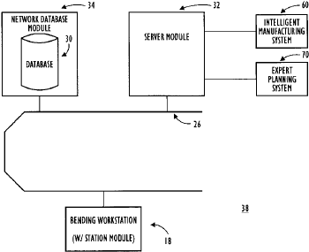
申请人：AMADA SOFT AMERICA INC
申请号：US08706830
专利类型：发明授权
申请日：1996-09-03
公开（公告）号：US5822207A
公开（公告）日：1998-10-13

97、High bandwidth, dynamically rigid metrology system for the measurement and control of intelligent manufacturing processes
标题（翻译）：用于智能制造过程测量和控制的高带宽、动态刚性计量系统
摘要：A high bandwidth, dynamically rigid metrology system for providing real time control of an optical steering element includes a pair of stabilized laser beam directors (SLBD), a reference subsystem, a tool sensor subsystem, and at least one processor. Each SLBD includes a base, a beam pointing and stabilization apparatus mechanically coupled to the base, three reference beam lasers and a stabilized beam laser attached to the base, and a metric structure which is mechanically coupled to the SLBD providing a locally rigid SLBD coordinate system. Each beam pointing and stabilization apparatus includes an optical steering element and an axis tilt detector. The optical steering element is optically coupled to the stabilized beam laser and steers the stabilized beam laser in response to an input signal. The optical steering element provides error signals associated with a position and an orientation of the optical steering element relative to the locally rigid SLBD coordinate system. The optical steering element further includes a rotational axis. The axis tilt detector provides signals indicating an angle of tilt and a direction of the rotational axis relative to an initial position of the rotational axis. The reference subsystem includes three reference detectors fixedly positioned relative to a workpiece providing a locally rigid workpiece coordinate system. The three referenced detectors are respectively in optical communication with the three reference beam lasers of each of the SLBDs. The reference detectors generate reference detector output signals in response to the reference beam lasers. The tool sensor subsystem includes at least one tool sensor detector positioned on a tool and in optical communication with the stabilized beam laser. The at least one tool sensor detector generates tool sensor detector output signals in response to the stabilized beam laser. The at least one processor receives and performs coordinate transforms on the referenced detector output signals and the tool sensor detector output signals to track a position of the tool relative to the locally rigid workpiece coordinate system. The at least one processor additionally receives and processes the angle of tilt and direction signals from the axis tilt detector and the error signals from the optical steering element to generate the input signal thereby providing real time control of the optical steering elements.
摘要（翻译）：一种用于提供光学转向元件的实时控制的高带宽动态刚性计量系统，包括一对稳定激光束定向器(SLBD)、参考子系统、工具传感器子系统和至少一个处理器。 每个SLBD包括基座、机械耦合到基座的光束指向和稳定装置、附接到基座的三个参考光束激光器和稳定光束激光器，以及机械耦合到SLBD的公制结构，该公制结构提供局部刚性SLBD坐标系。 每个光束指向和稳定装置包括光学转向元件和轴倾斜检测器。 所述光学操纵元件光学耦合到所述稳定光束激光器，并响应于输入信号操纵所述稳定光束激光器。 光学转向元件提供与光学转向元件相对于局部刚性SLBD坐标系的位置和定向相关联的误差信号。 光学转向元件还包括旋转轴。 轴倾斜检测器提供指示旋转轴相对于旋转轴的初始位置的倾斜角度和方向的信号。 基准子系统包括相对于工件固定定位的三个基准检测器，所述基准检测器提供局部刚性工件坐标系。 三个参考检测器分别与每个SLBD的三个参考光束激光器进行光通信。 参考检测器响应于参考光束激光器产生参考检测器输出信号。 所述工具传感器子系统包括至少一个工具传感器检测器，所述工具传感器检测器定位在工具上并与所述稳定光束激光器进行光通信。 所述至少一个工具传感器检测器响应于所述稳定光束激光器产生工具传感器检测器输出信号。 所述至少一个处理器接收所述参考检测器输出信号和所述刀具传感器检测器输出信号，并对所述参考检测器输出信号和所述刀具传感器检测器输出信号执行坐标变换，以跟踪所述刀具相对于所述局部刚性工件坐标系的位置。 所述至少一个处理器附加地接收和处理来自所述轴倾斜检测器的倾斜角和方向信号以及来自所述光学转向元件的误差信号，以产生所述输入信号，从而提供对所述光学转向元件的实时控制。
首页附图：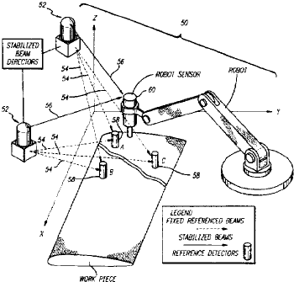
申请人：KYRAZIS; DEMOS
申请号：US08518106
专利类型：发明授权
申请日：1995-08-22
公开（公告）号：US5666202A
公开（公告）日：1997-09-09

98、PROCESS FOR PREPARATION OF DEHYDRATION AND REINFORCEMENT AGENTS OF PAPER MANUFACTURE
标题（翻译）：脱水的制备方法和加固剂的纸的制造
摘要：adding 10-100 parts of one selected among water-soluble starch, monosaccharide or polysaccharide to 200-250 parts of formaline; controlling pH to 3-10 with one of glacial acetic acid or formic acid, heating to 50-100 deg.C, reacting until the content becomes a fully transparent solution; controlling the pH of it to 7-10.5 with alkaline solution, adding 30-100 parts of urea or melamine, and reacting at 50-100 deg.C for 20-90 min. to obtain a reacted product; adding 30-100 parts of methanol or ethanol and 5-20 parts of one selected among diethylene triamine, triethylene tetramine or polyamine, controlling pH to 3-6 and reacting for 5-60 min.; neutralizing with alkaline, removing the unreacted formaline and cooling.
摘要（翻译）：传统的推进轴由惯性在限位钢筋效果和旋转脱水桶的方法具有同时困难。因此，相关联的一组与造纸脱水装置连接有ADSL换句话说，VDSL[…]的组成部分，甲酰胺部分，齿优惠券，[…]拆卸rollwall可能性即脱水或用于干燥等干燥轴线X，Y方向的节能所述得多的增速和纸的同时增强和加固效果。福尔马林附<β]的化学容器中的搅拌器200-250份导入部的单糖或多糖或水溶性淀粉和10-100ph3-10/1公斤水。5L或冰醋酸地面防止太小部分控制，它适当地加热到50°C-100°C完整清晰的搅拌溶液至反应，在钠或钾的氢氧化物或氢氧化物，如铵氢氧化物形成溶液ph7-105碱水溶液，和其中三聚氰胺元件和安装在盘和调节到30-10020成分50°C-100°C再次地避免太小部分90分钟，在甲醇或乙醇的减少稻瘟病的30-100的损坏和二乙烯三胺或三亚乙基四的无胺或其他多元胺5-20ph3-6地面防止太小部分具有低熔点锡反应分钟5-60控制电路产生电特性控制聚合达到福尔马林未反应的中和碱溶液表面去除和冷却造纸脱水的由聚合物材料和加强剂即得。
申请人：KIM CHANG KYU
申请号：KR1019910012265
专利类型：发明申请
申请日：1991-07-18
公开（公告）号：KR19930002610A
公开（公告）日：1993-02-23

99、METHOD AND SYSTEM TO AUTHENTICATE AUTHORIZATIONS
标题（翻译）：方法和系统，以验证授权
摘要：Methods and systems for the authentication of accreditation or messages and of message signatures. Instead of using multiple accreditations and an iterative verification process, deep-level accreditation is adopted (high exponent p), and a number D between 0 and p-1 is drawn at random. The verification operations include calculation of the Dth power of the inverse accreditation B. The invention is used particularly for chip cards and more especially for bank cards.
摘要（翻译）：[目的]零-识别方法保证合格的消息或一认证与保证的方法涉及消息显示和系统用于携带进行方法和一种多个的显示通过-中使用的方法和系统提供站。[配置]在该消息的所述背景信号，消息M的治疗和营养剂，它释放所述实体的公共密钥(N，P)以共操作。用于报告所述消息之前，输送到所述整数N的模环组件还适于添加的术语，用于获取，N个模信号线和在所述相同的时间(P)的功率的倒数D到提高所述部件。公共密钥的秘密参数的初始其它字的两个实体中保持因子(A和B)具有所述D。签名和unsubstantiated，控释矩阵图形输入板与该实体消息的地址相关联的公共密钥(N，P)，其是通过使用获得的一个，用于加工一个消息的系统，用于编码一个提供单元提供所述自动产生的分量N个图形控制器SP模式。通过检查所述的术语，地址可以处理该消息和，要执行相同的消息是以只发送实体。
首页附图：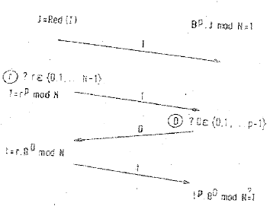
申请人：PHILIPS NV; FRANCE ETAT; TELEDIFFUSION FSE
申请号：KR1019880011581
专利类型：发明申请
申请日：1988-09-07
公开（公告）号：KR19890005634A
公开（公告）日：1989-05-16

100、Smart Manufacturing System for Machinery Industry
标题（翻译）：一种用于机械行业的智能制造系统
申请人：NATIONAL CHENG KUNG UNIVERSITY
申请号：US62475889
专利类型：发明申请
申请日：2017-03-24
公开（公告）号：US62475889P0

